CI PIPELINE USING THE YAML

1. Previously we are triggering the Build and now we can use the YAML which is the flexible format

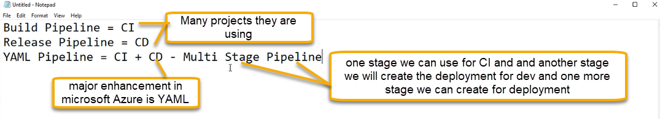

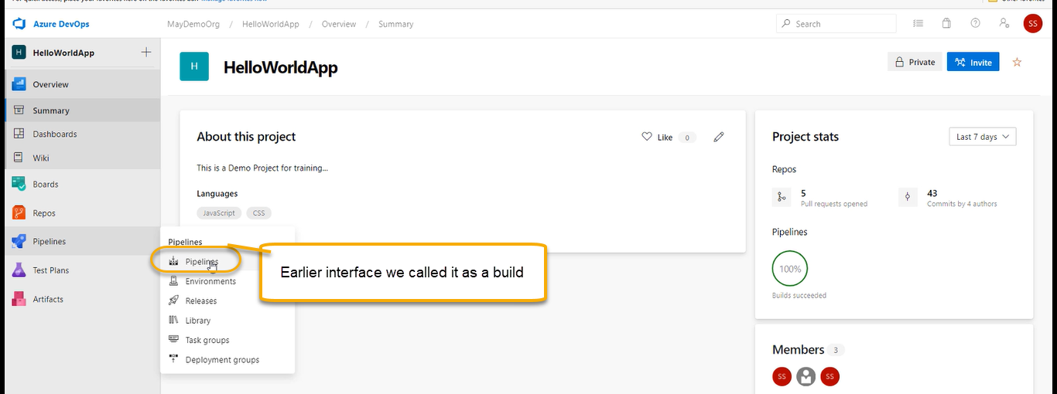

And we separate menu for Release pipeline as shown above

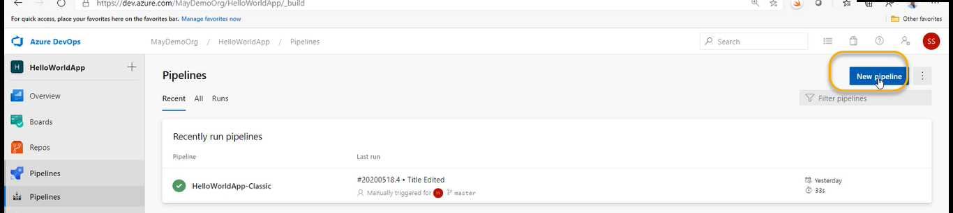

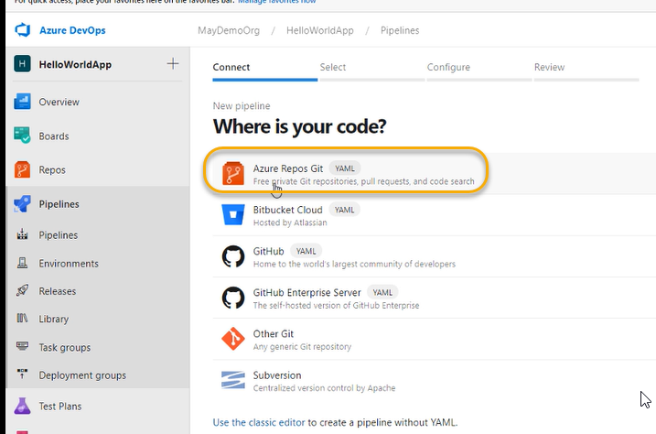

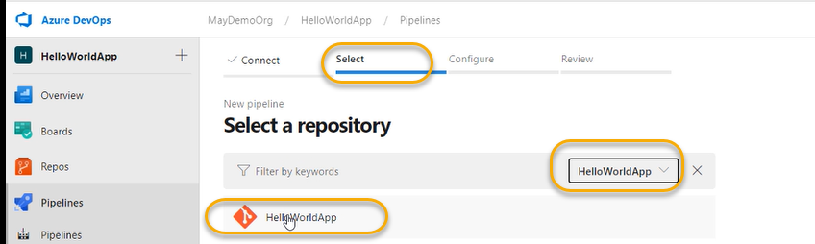

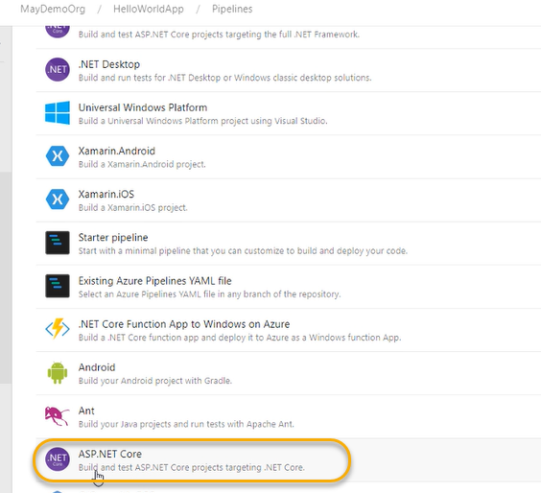

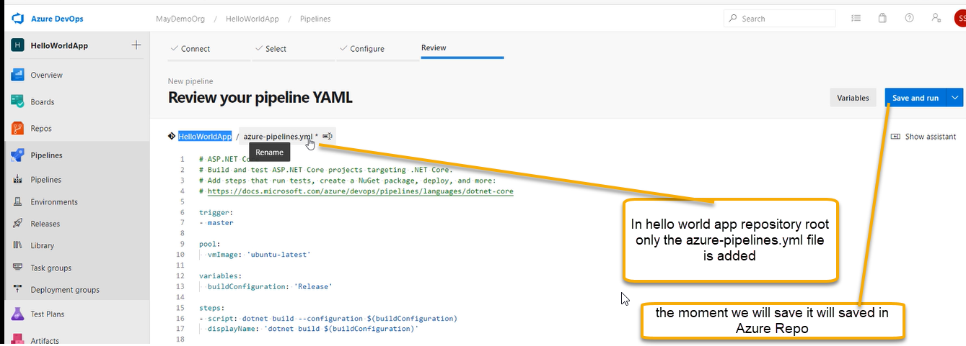

After saving the file we can probably pull this file

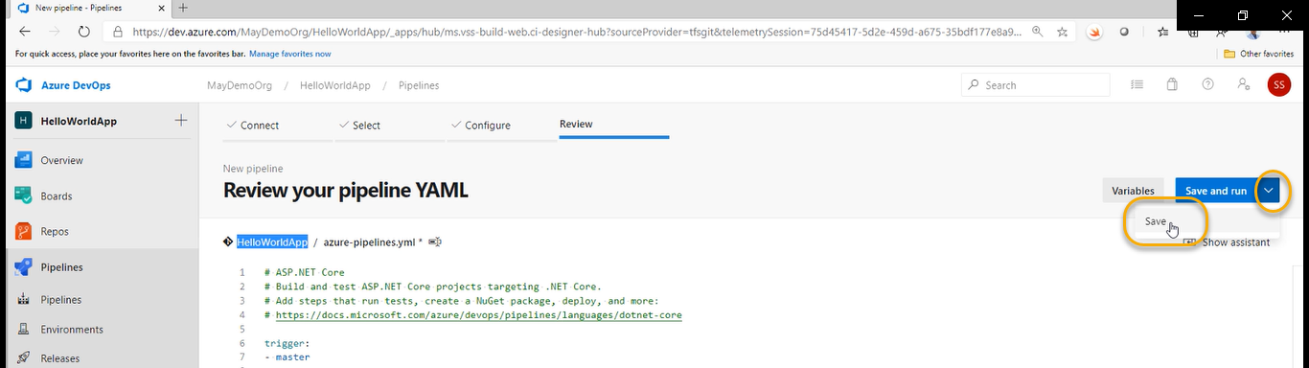

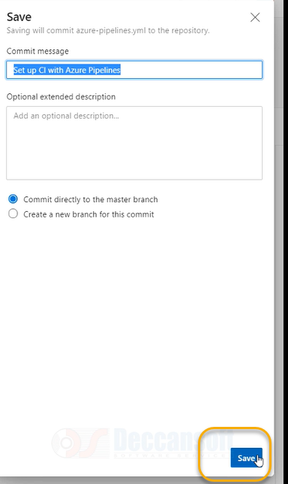

The moment if you click on save, we see that RUN has started

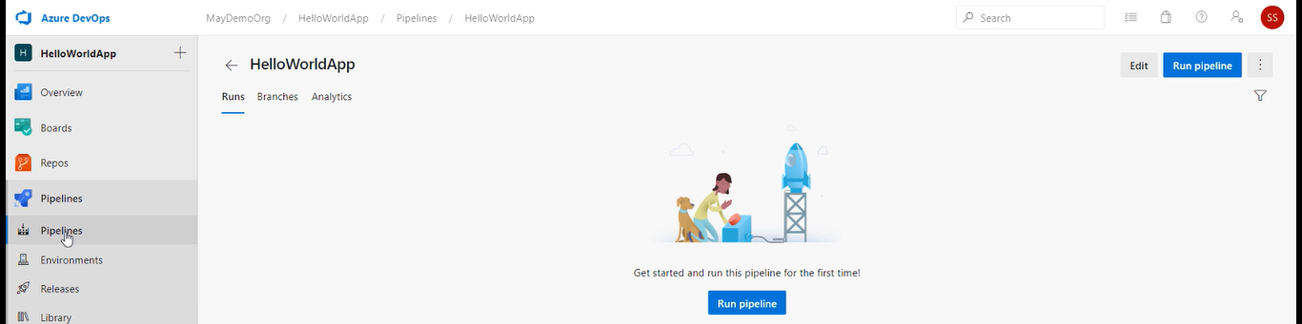

We need to give a better name

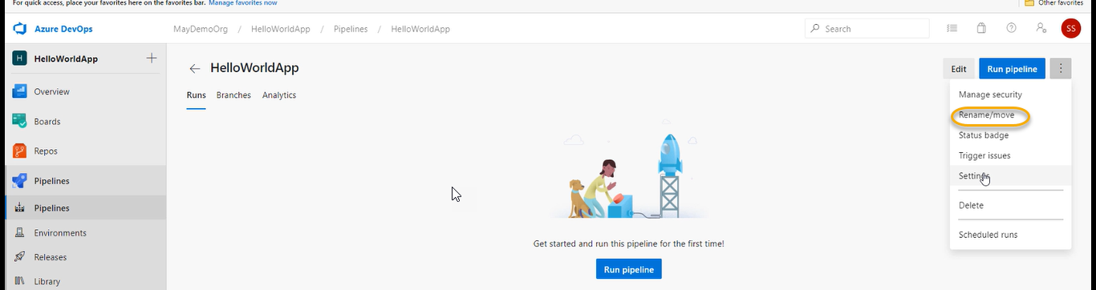

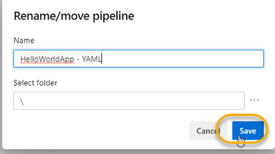

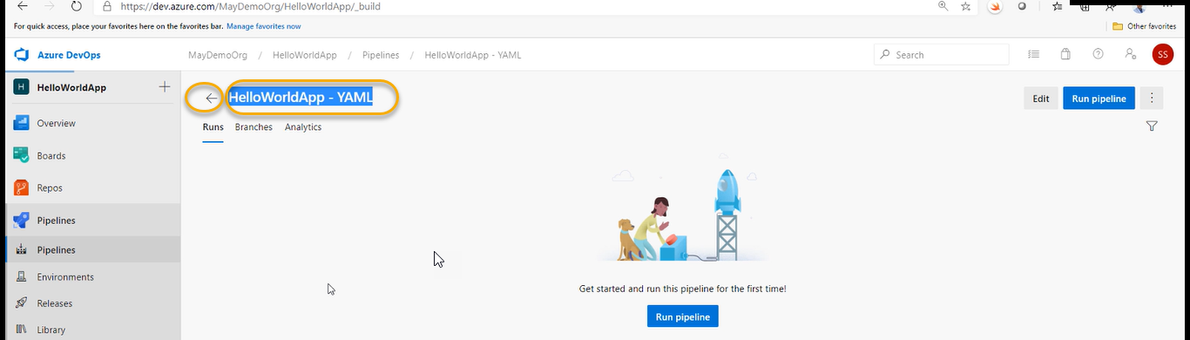

Click on Back

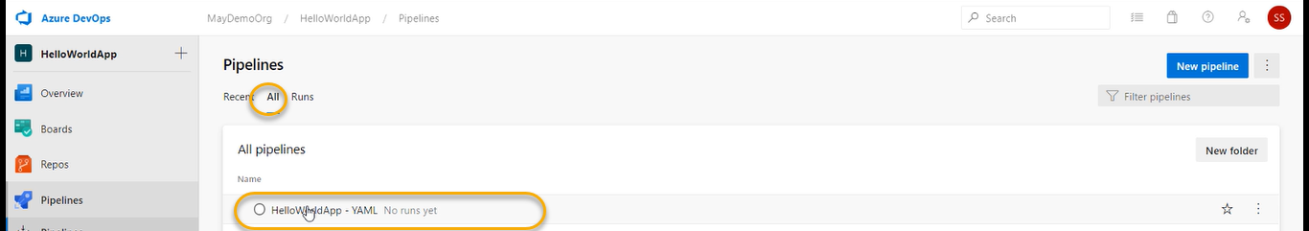

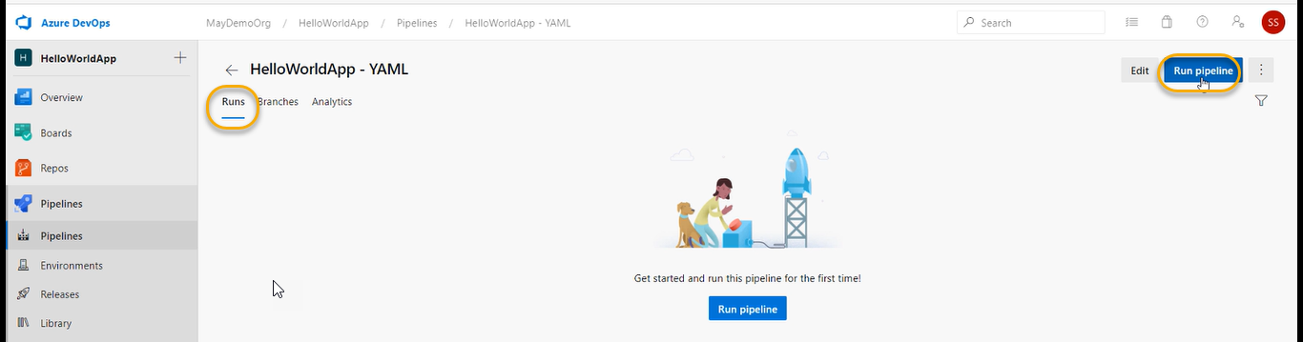

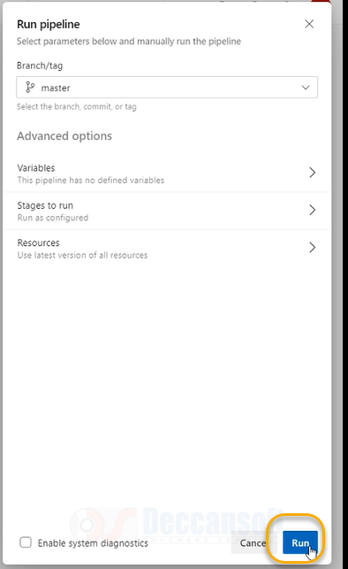

The moment you will Run it will start the Job

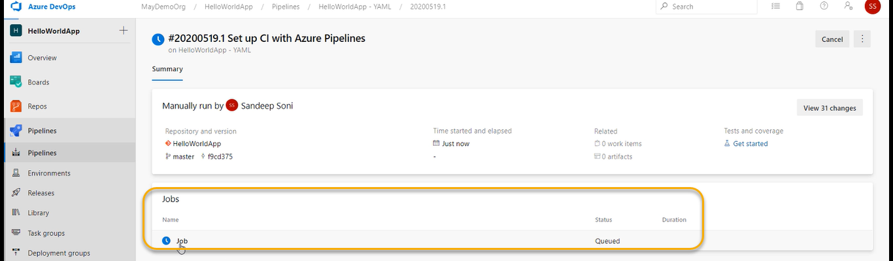

Click on the Job

We can see the tasks are running

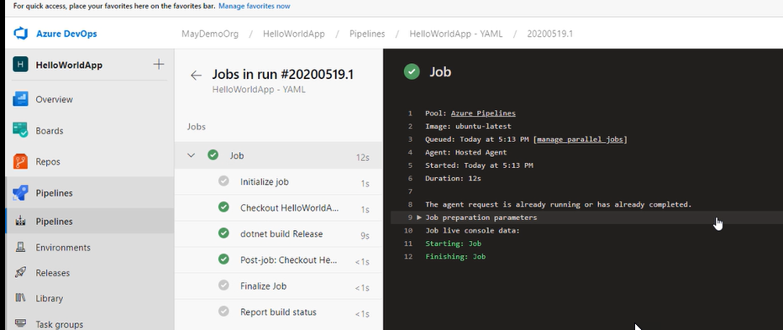

The steps are NOT there for Artifacts that’s why it is not generated

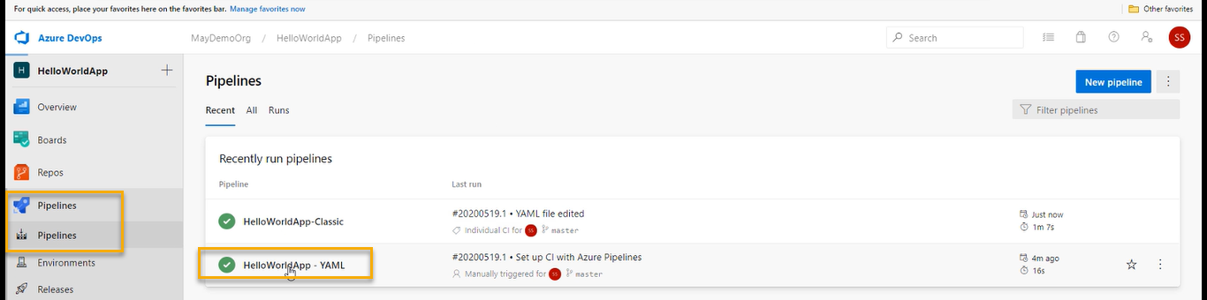

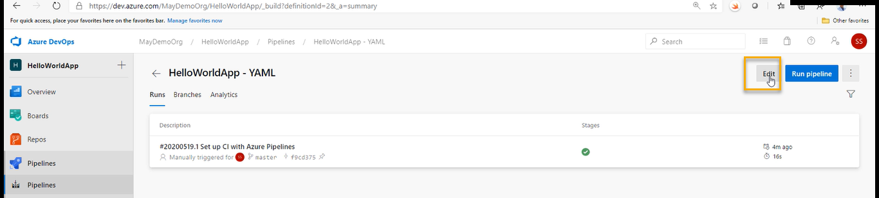

Instead of editing the above we can do it in cmd

Now we need to pull the code

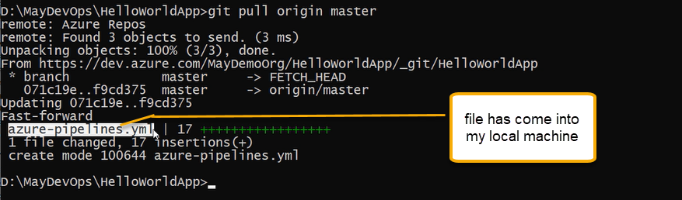

Edit the code locally

Code .

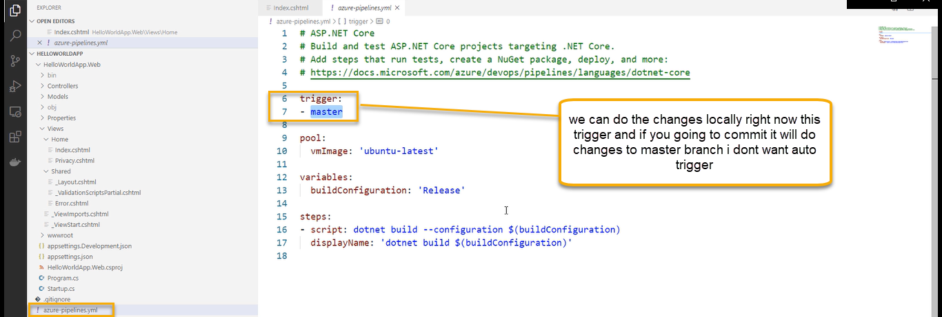

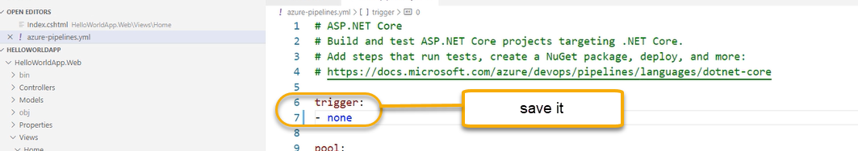

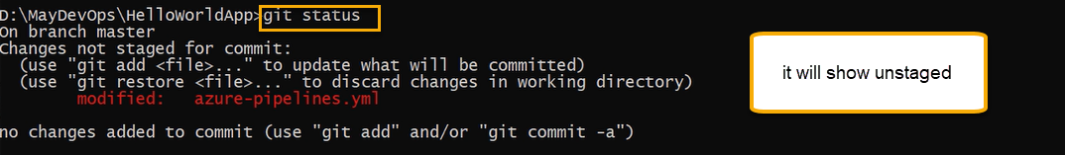

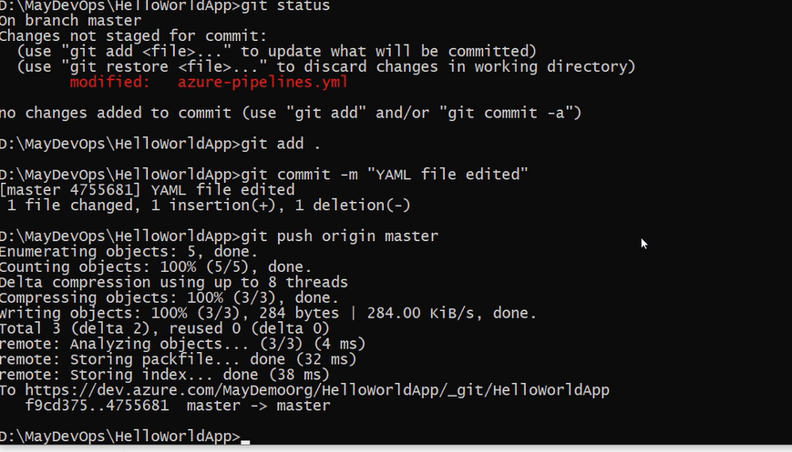

YAML Advantage without going/accessing to Azure portal we are able to edit the code from source code from source code which is in the repository there only we can have YAML file

Even developers can edit the YAML steps

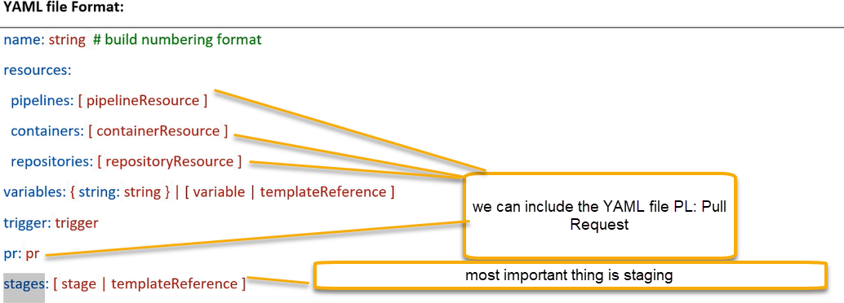

jobs

We are going to create the separate stage for each environment

A job is a linear execution of steps for execution of Job we need agent if there are 10 jobs, we can run parallelly provided by Microsoft purchased by Microsoft which is paid one. We can tell which job runs first or after completion of first job the fifth jobs has to run we can predefine it

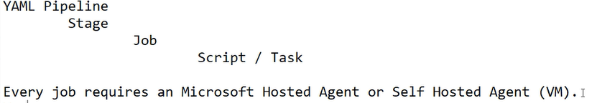

After generating the YAML file we can edit the YAML file

We would like to run own tasks and scripts

We can go local editor and edit the code

code .

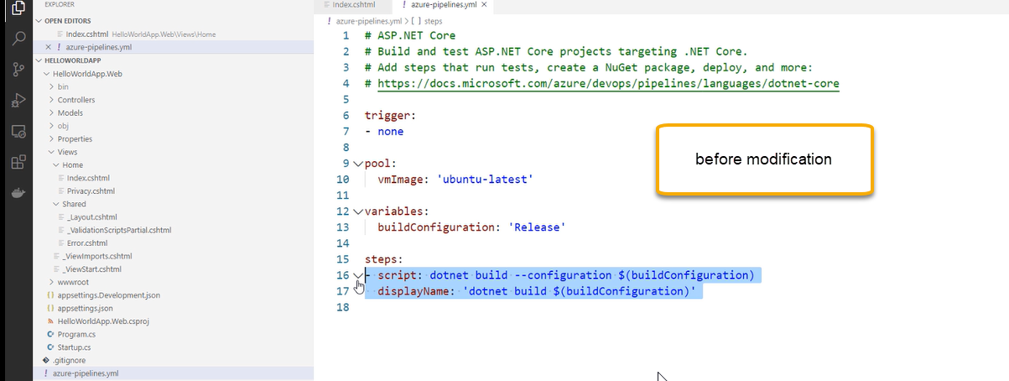

We need to know the format of the task and scripts when we are actually editing

YAML is very sensitive and critical in terms of away how use the enter, colon, spaces, and ‘-‘and colon, double cots

YAML files initially we will get error and we need to practice.

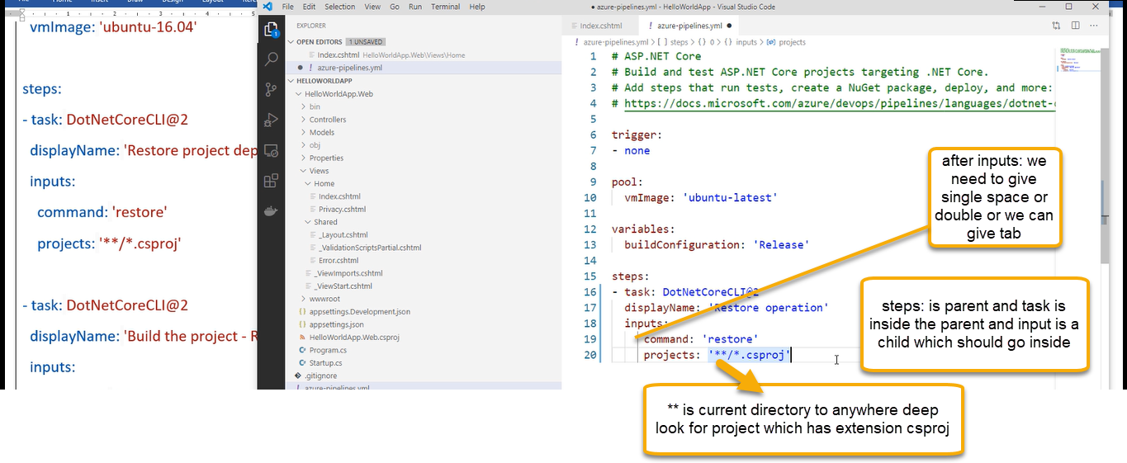

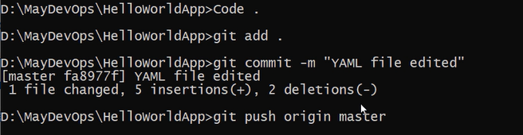

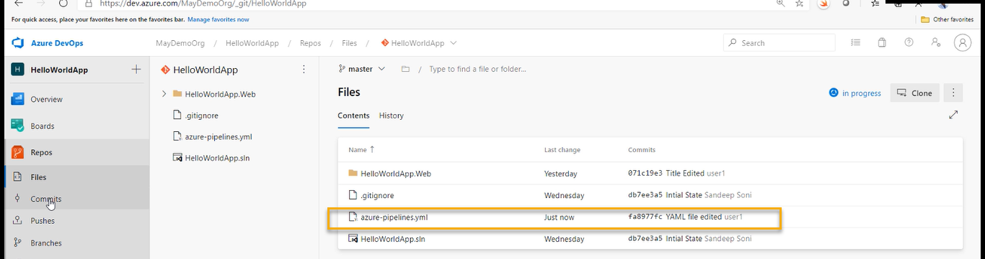

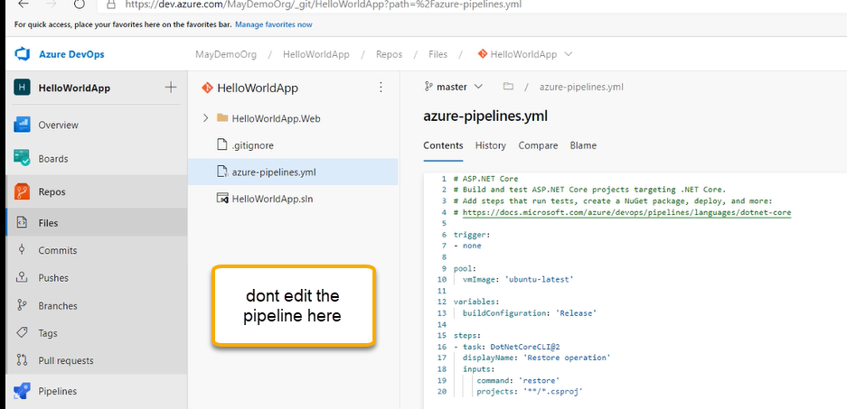

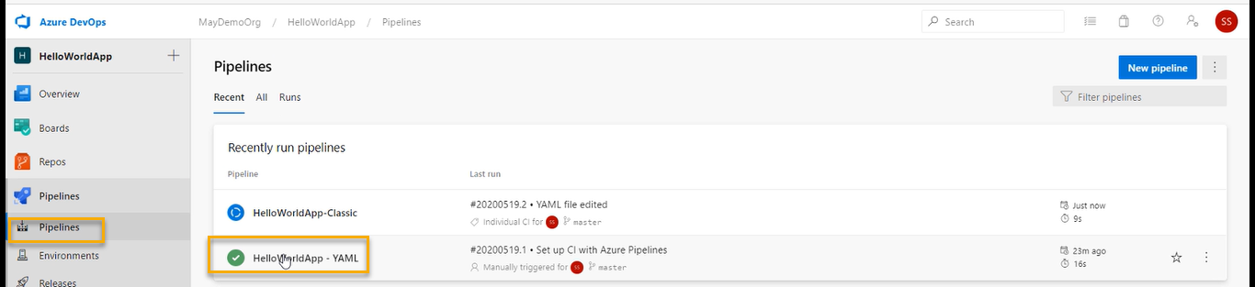

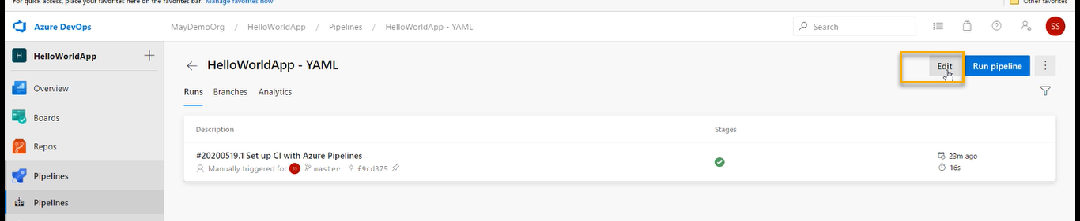

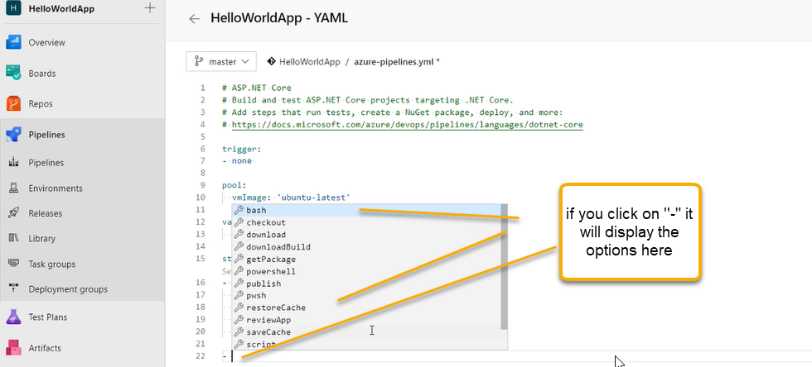

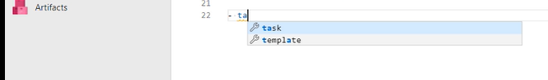

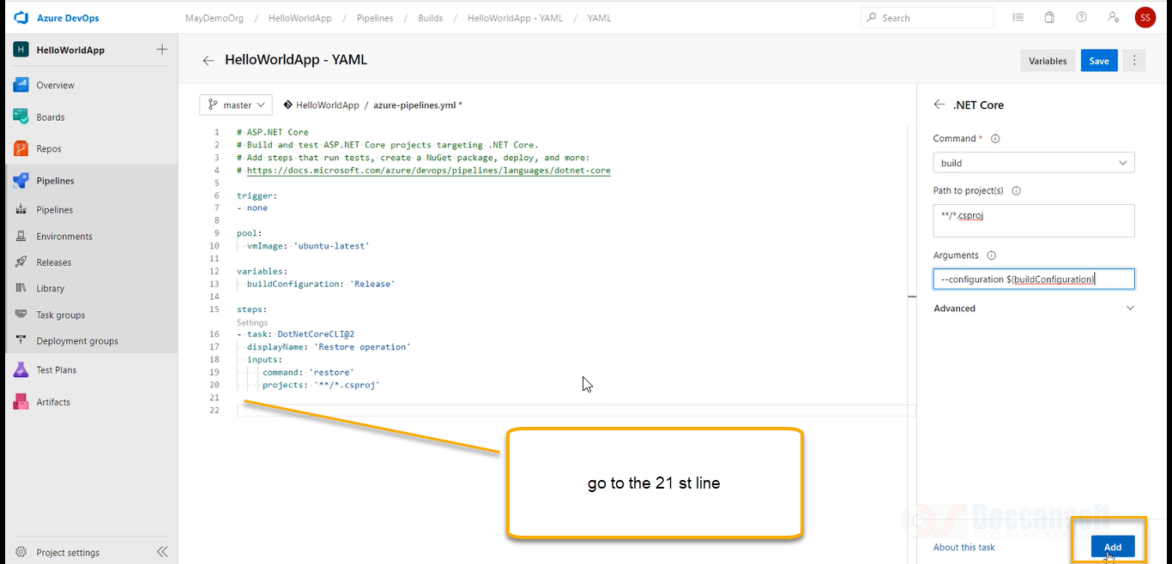

With respect to above screenshot Build is a task if you click on Add we can see steps are added

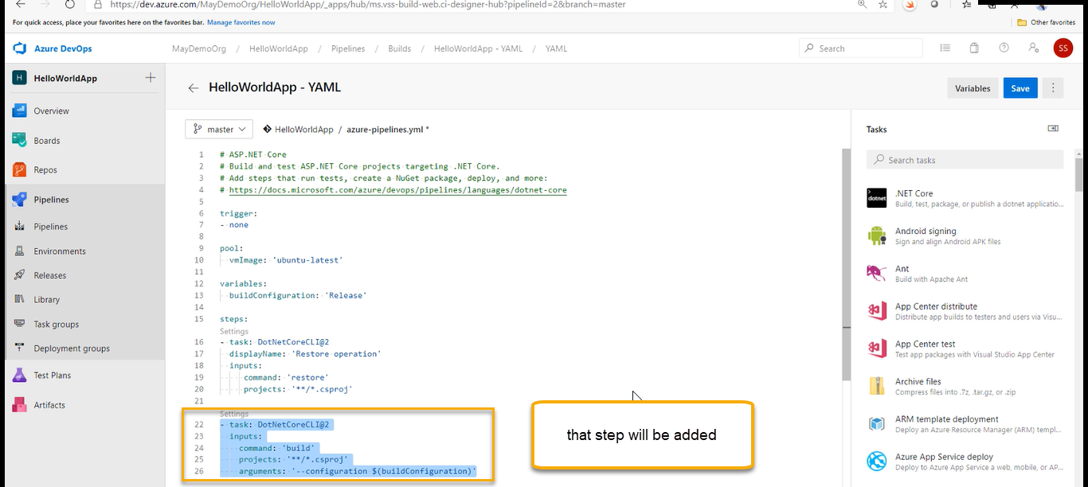

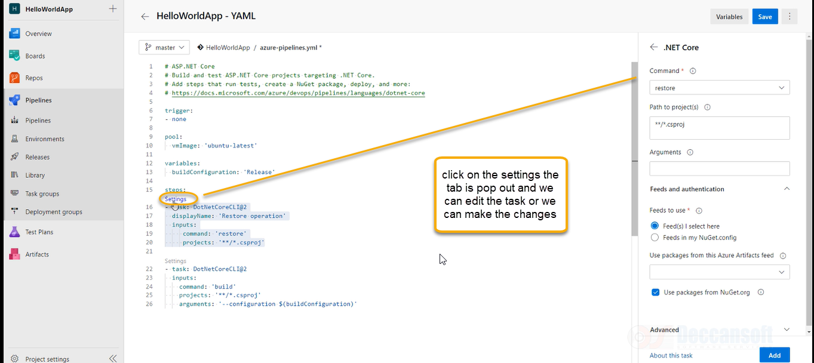

Build and publish operations: we need to check with developers what are the arguments you are passing.

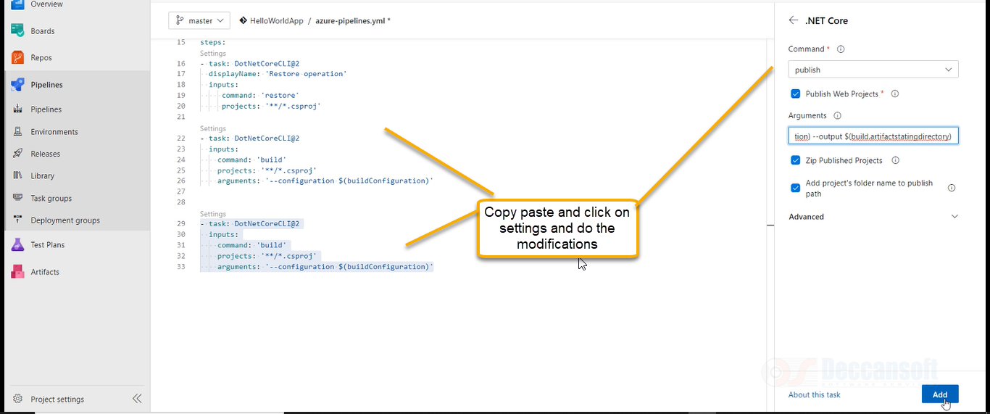

Publish web projects: Applications related to web will be taken here

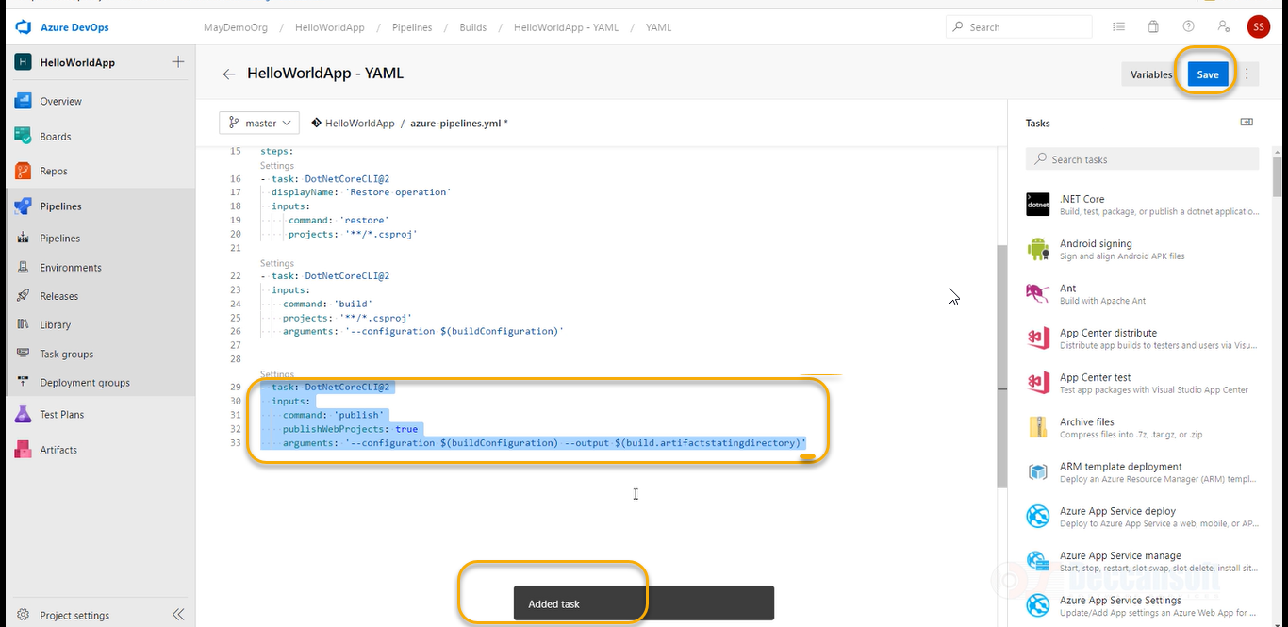

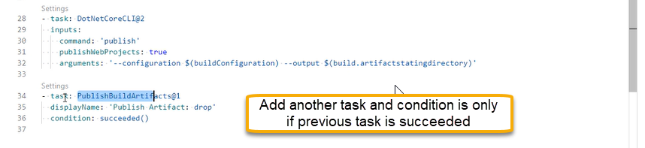

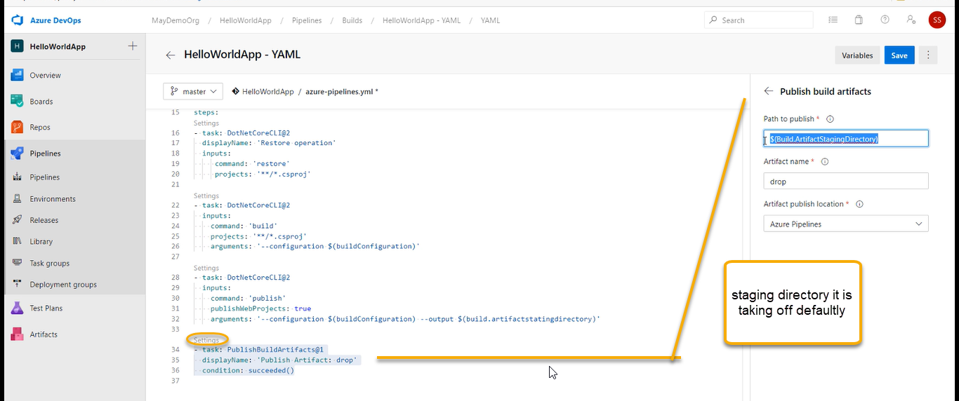

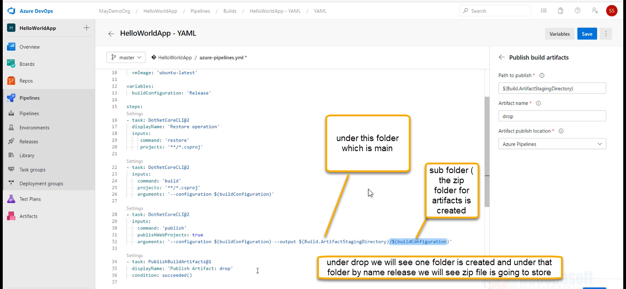

For java and python we may have different tasks.

As a devops engineer we need to learn with developers and how they are going to perform this tasks manually

Click on save as we see In the above screenshot

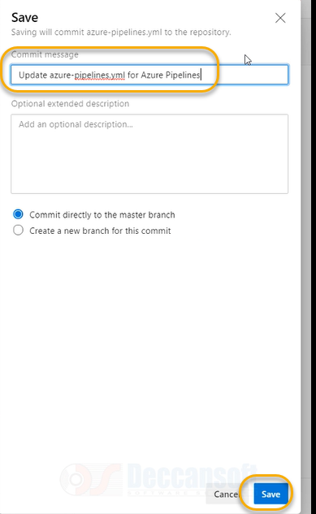

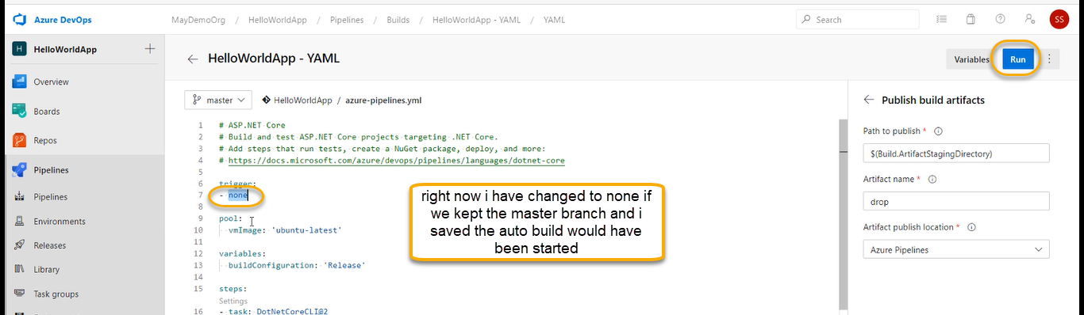

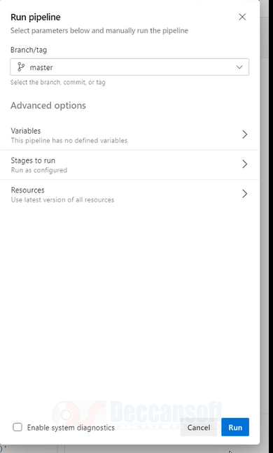

A new job is created

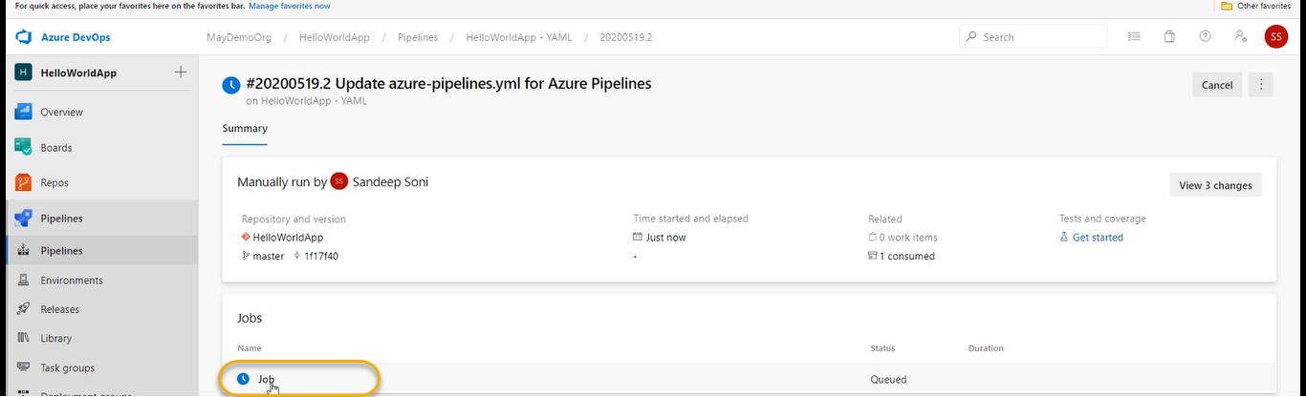

Before that we need to uncheck the below options in the classic module

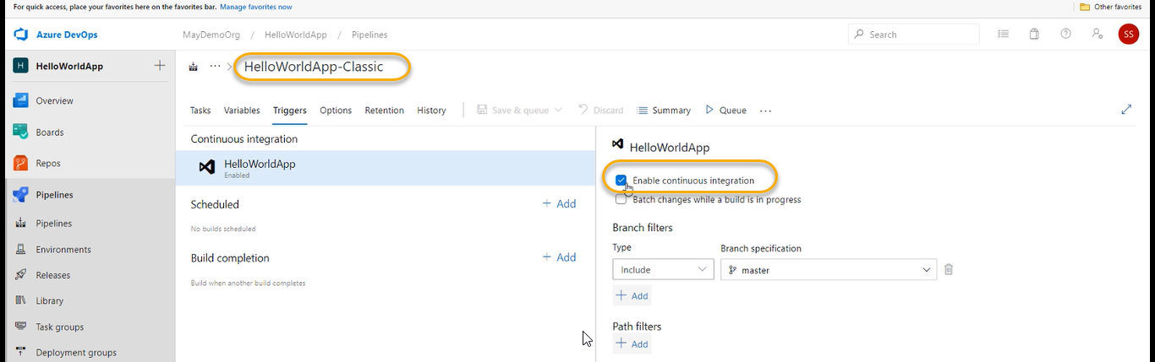

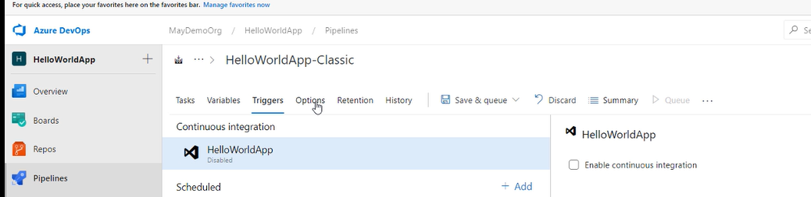

Or we can go to the options

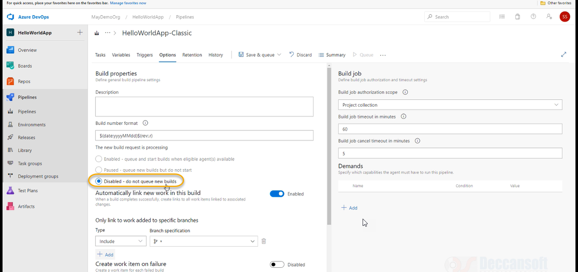

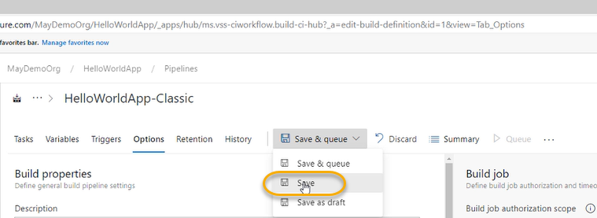

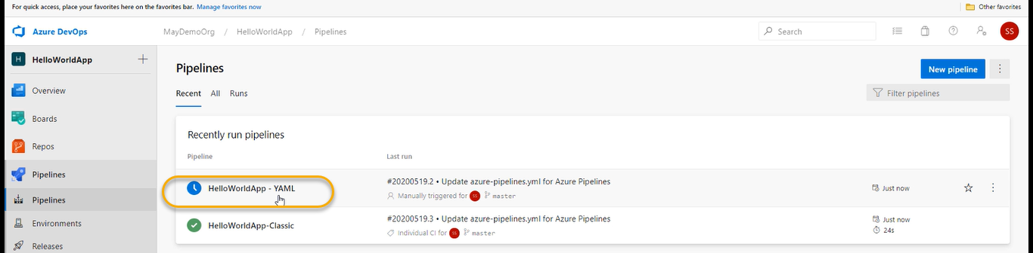

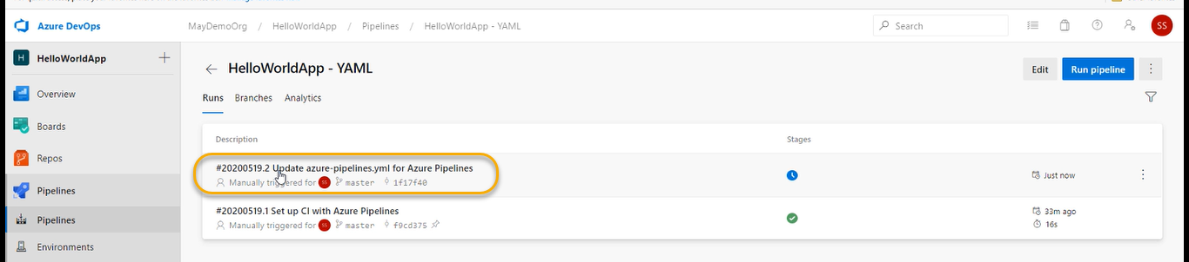

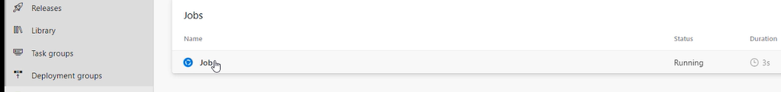

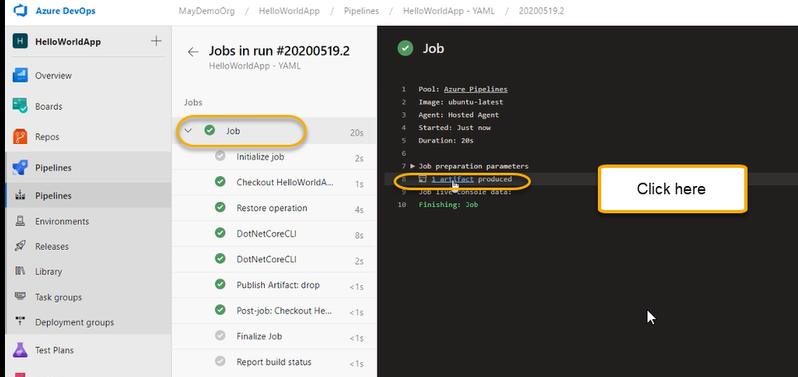

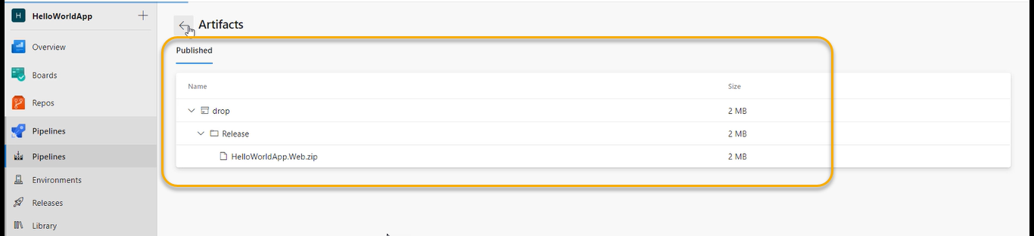

Try creating the intentional error

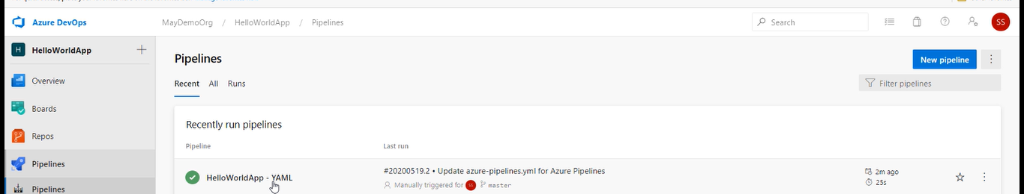

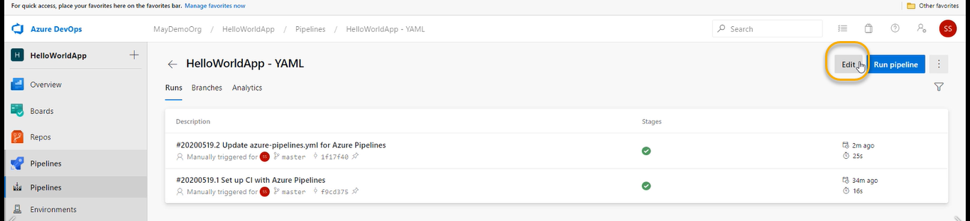

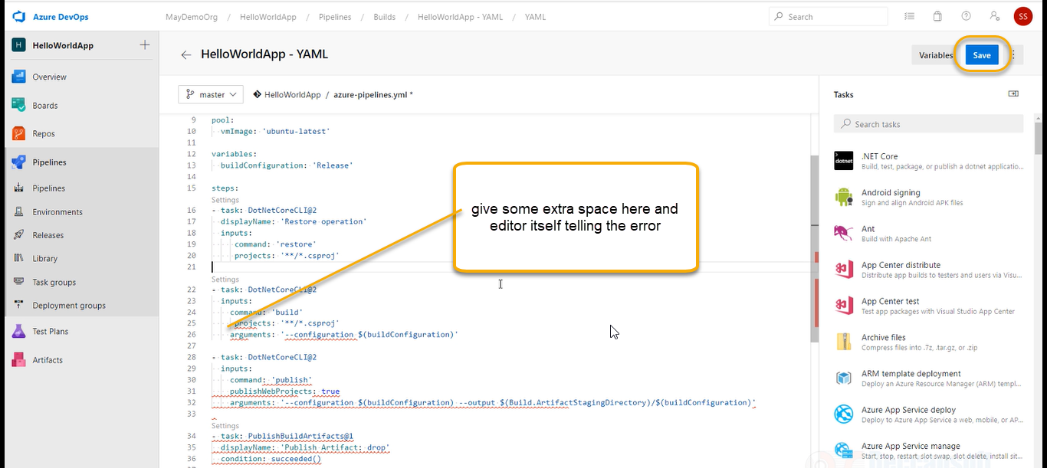

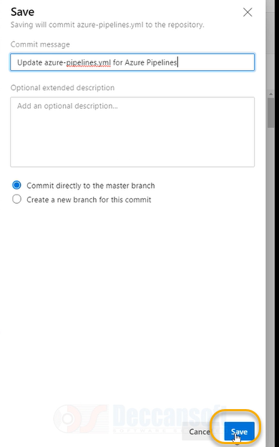

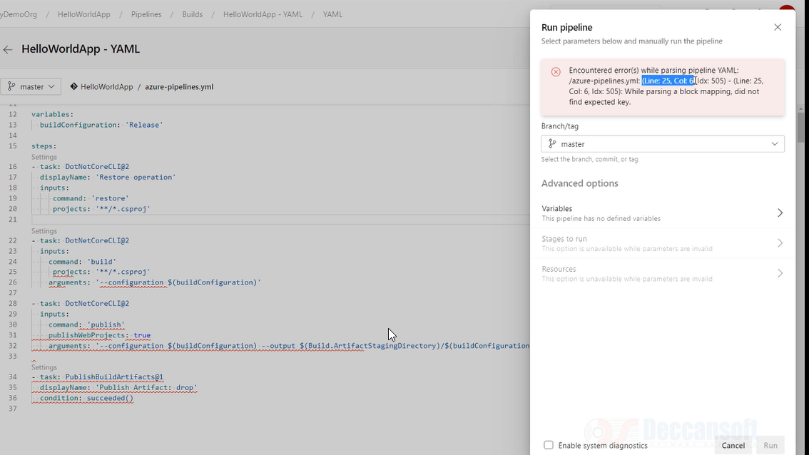

As of now we have not created any stage or Job default the job is created.

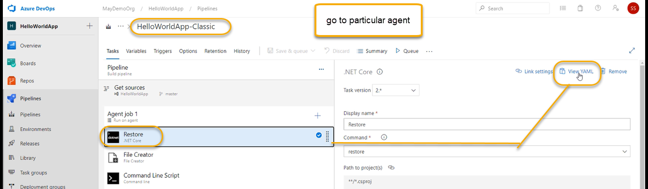

You can copy this

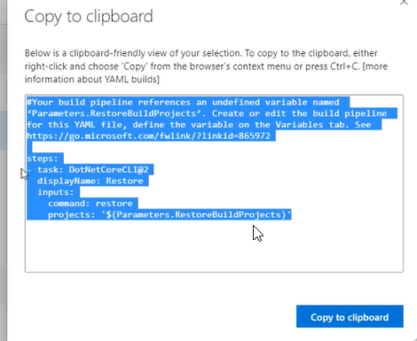

Classic you are not getting local copy and YAML we are going to get the local copy where developer can edit it the tasks if developers do the mistake then we have source code control of it we can go to previous commit and we can use it

How automatically YAML will triggers(Triggering CI in YAML)

1. Previously the trigger is none and if we made to master

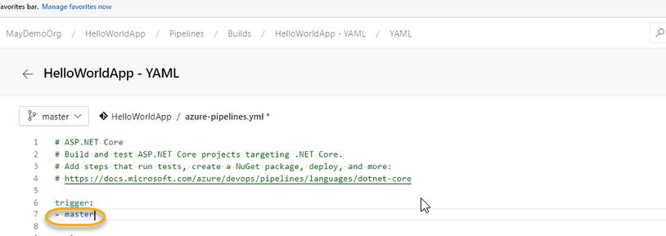

1. Azure-pipeline.yml is one file in master branch and save the file

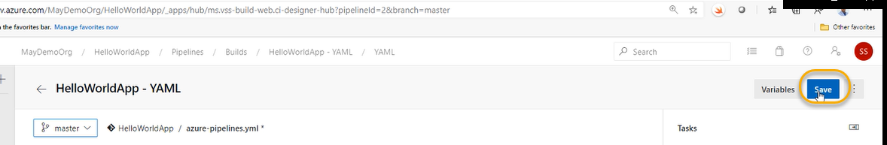

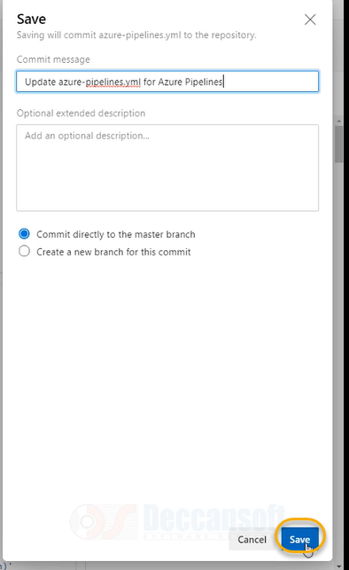

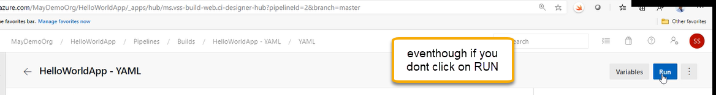

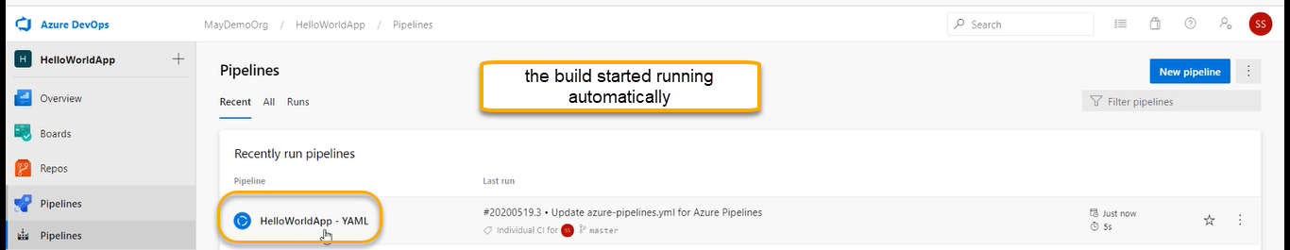

Or we can go the below navigation

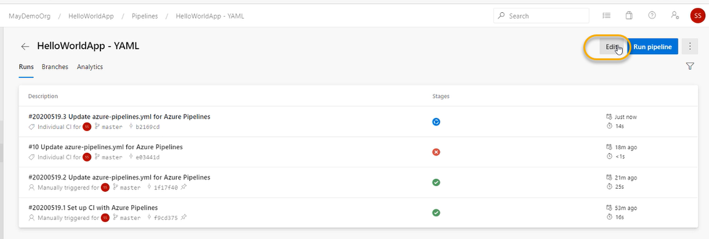

And we can choose triggers

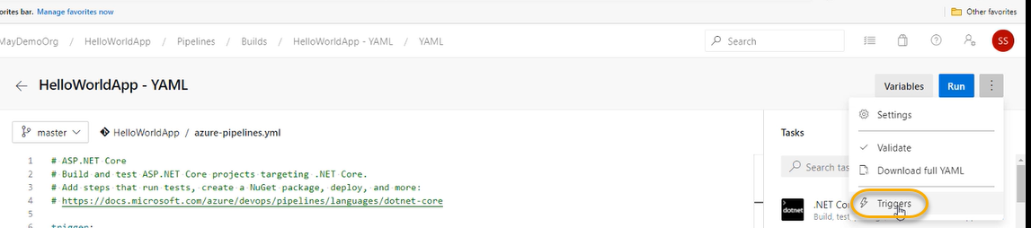

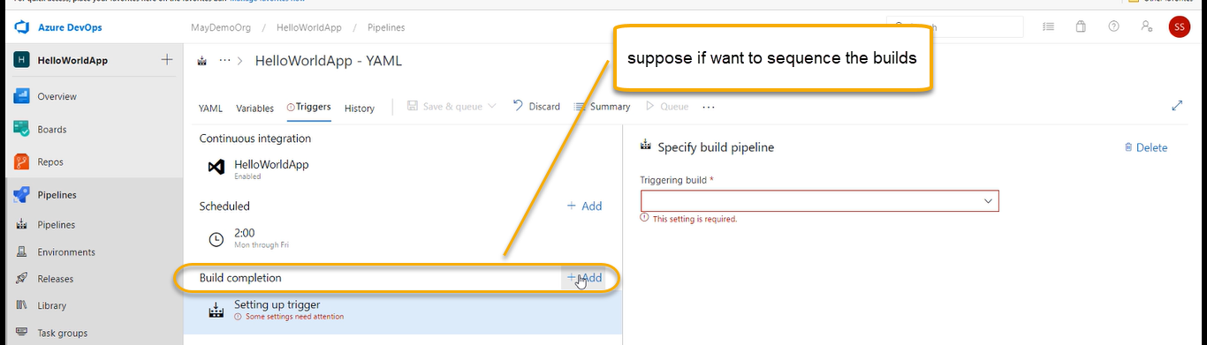

If one build is completed

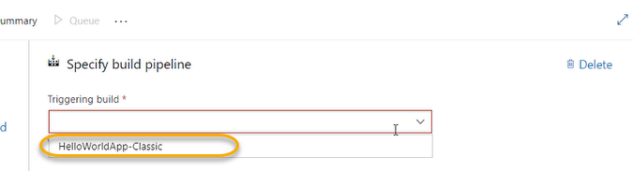

Automatically trigger this build

Since both builds are in the same projects, we will not see much difference

If they are multi projects, you can sequence the build one after the other

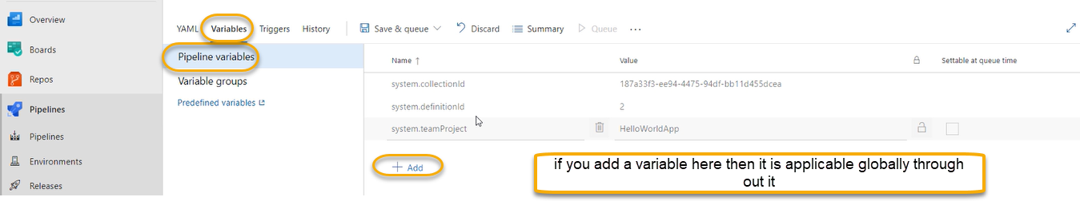

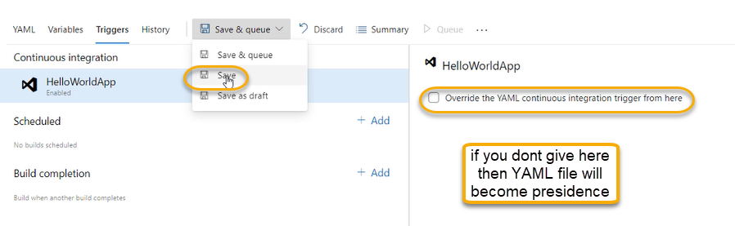

Go back to pipeline and edit

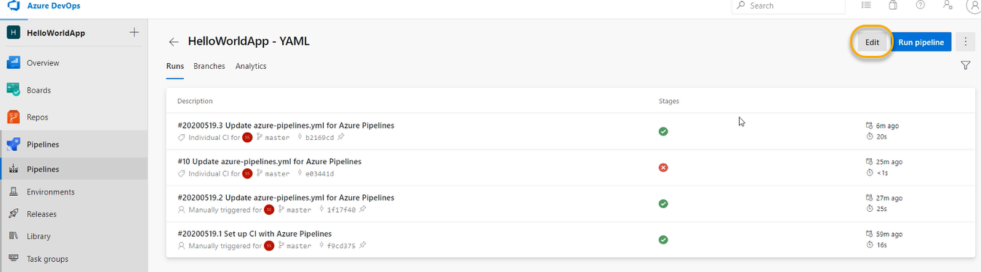

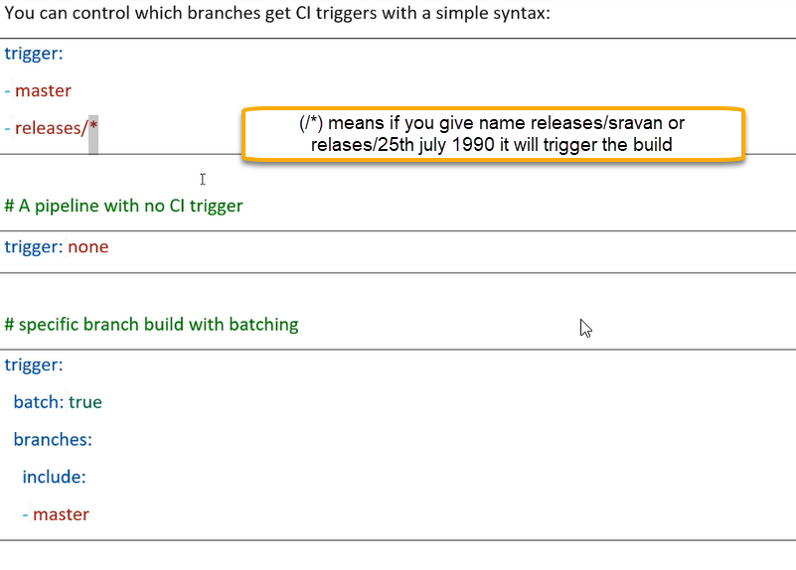

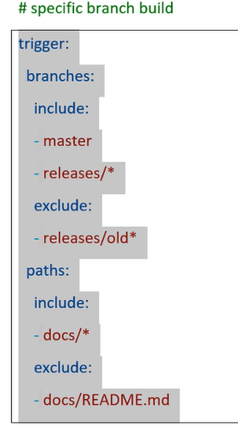

-docs/README.MD (Other than read me) trigger the build

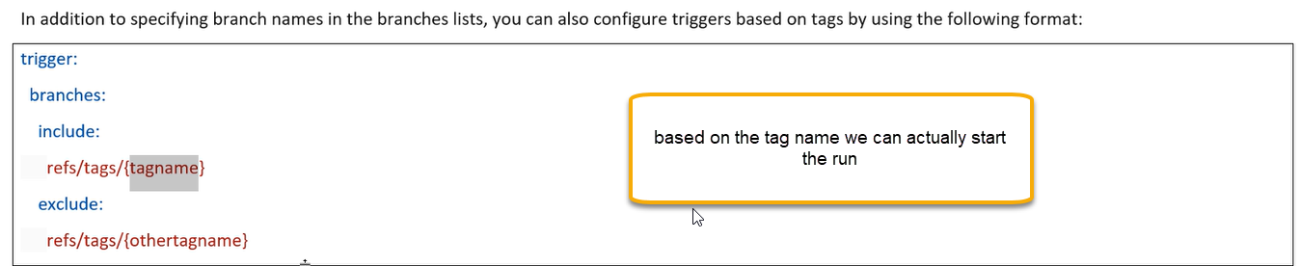

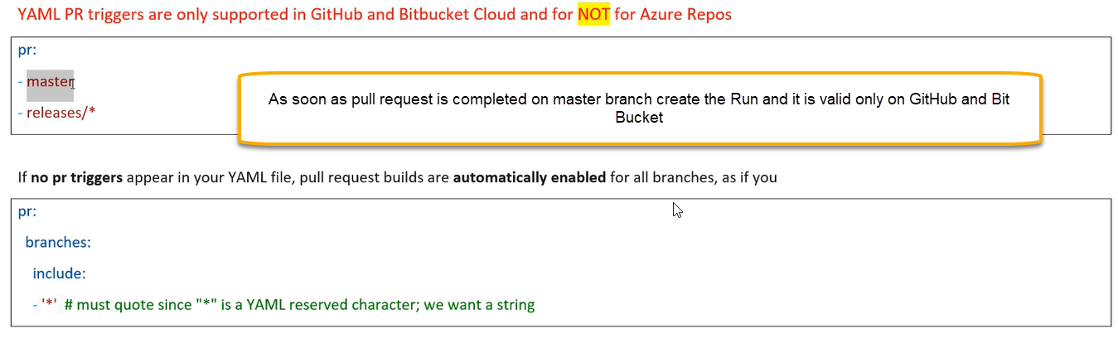

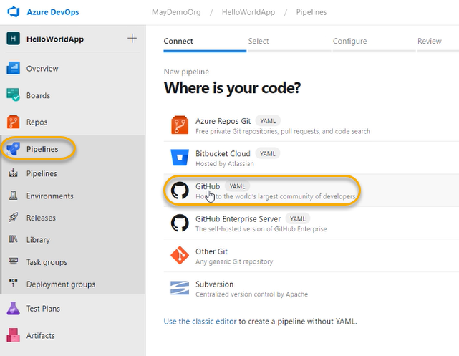

We need to connect a service connection to git hub

Randomly take some project

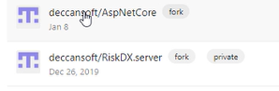

It is automatically navigating to git hub credentials page

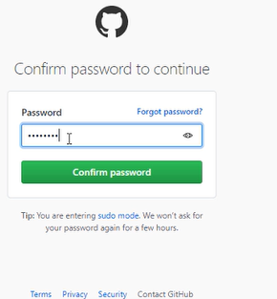

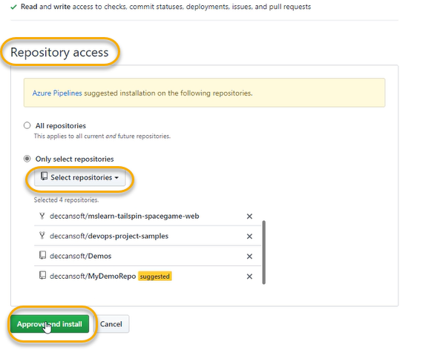

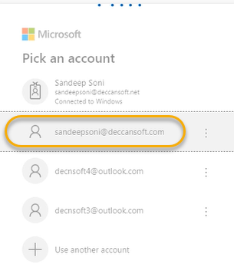

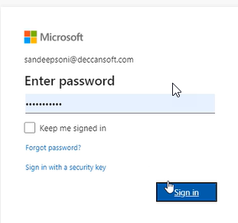

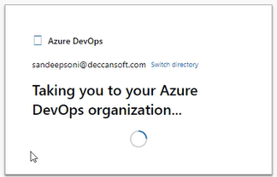

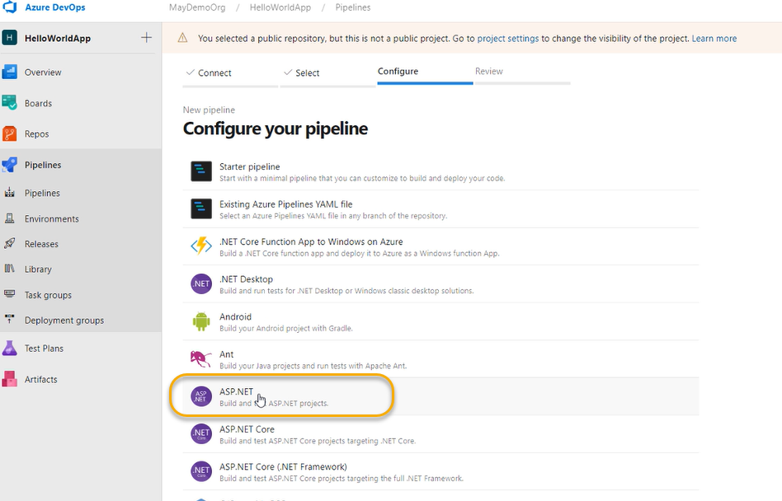

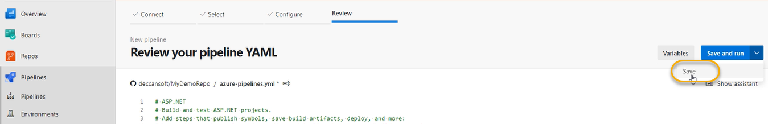

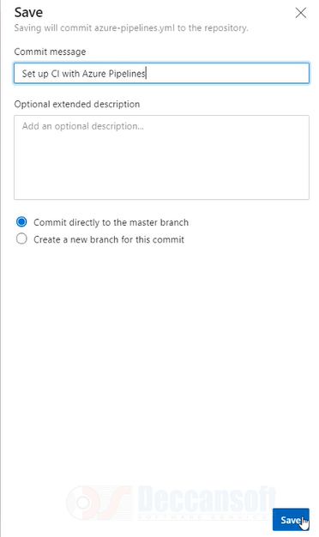

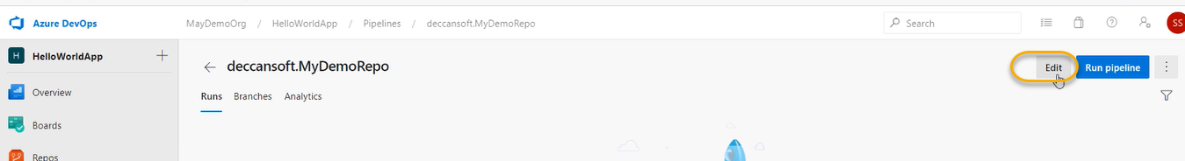

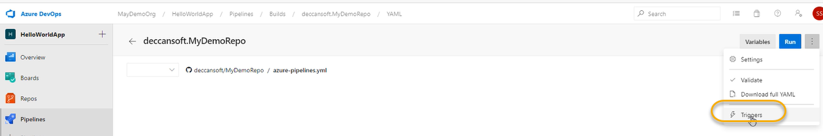

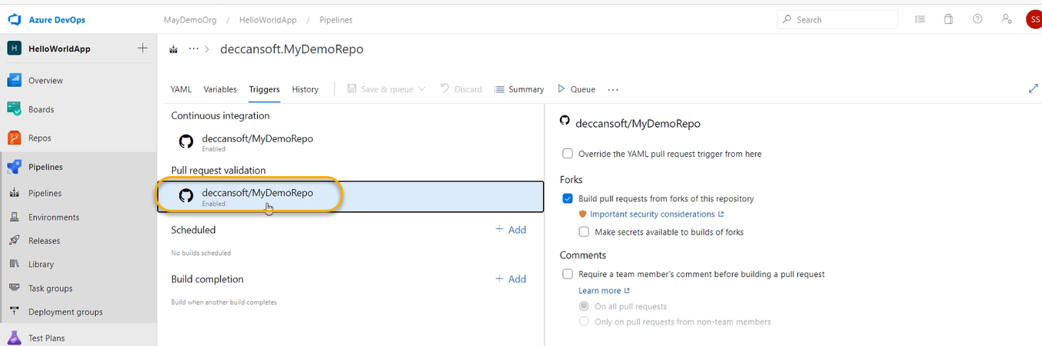

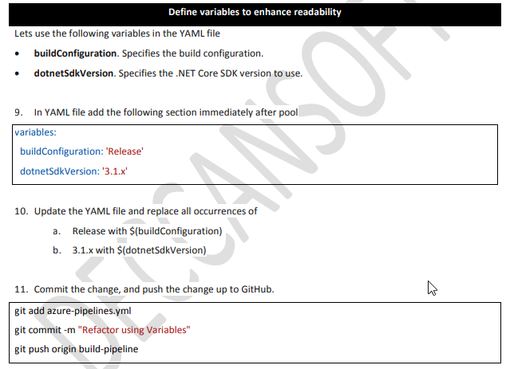

Reusing tasks using templates in YAML

In classic pipeline we have created the task group and the same we can do it from YAML using templates

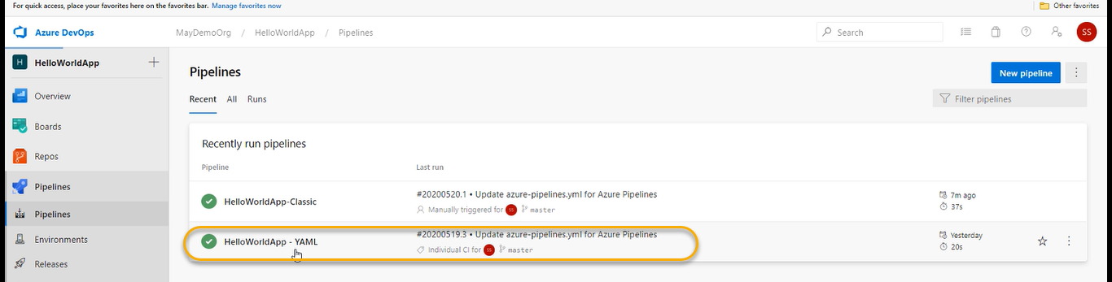

YAML pipeline is based on YAML file

Under the root directory only we have created the YAML

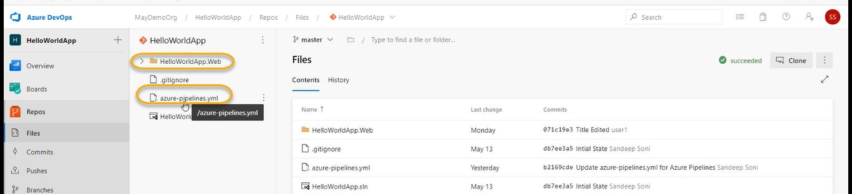

May be at the same level

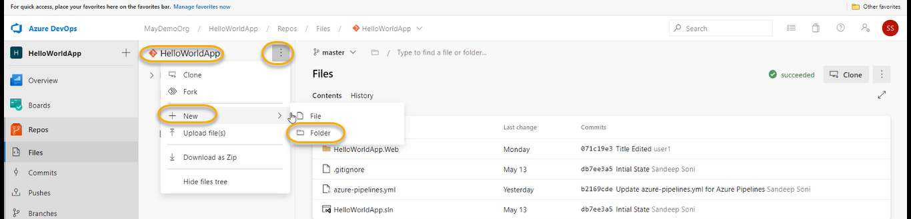

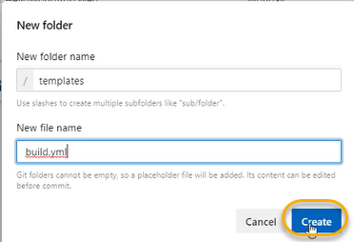

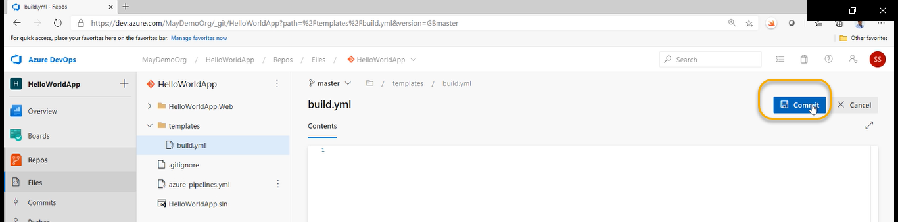

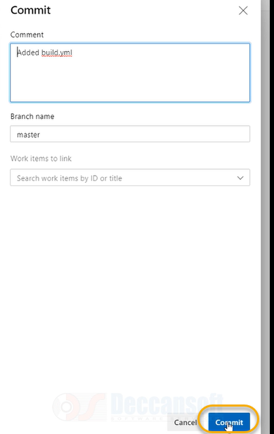

In azure-pipelines.yml we have got sometasks and all the tasks which you want to group in the YAML file

Copy the build and publish and paste in build.yml

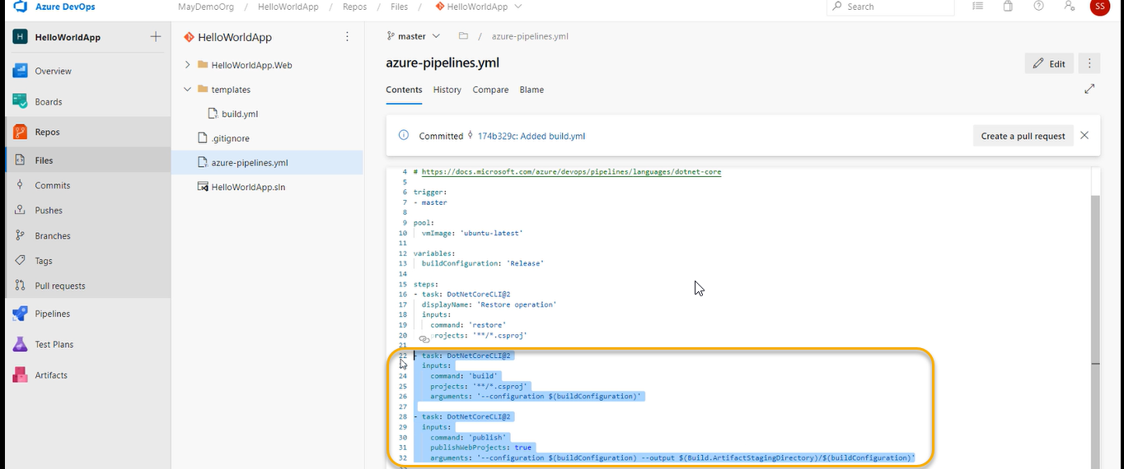

Go to build.yml file and paste

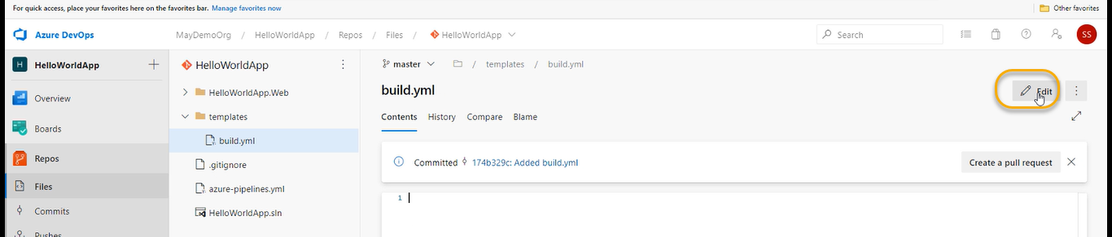

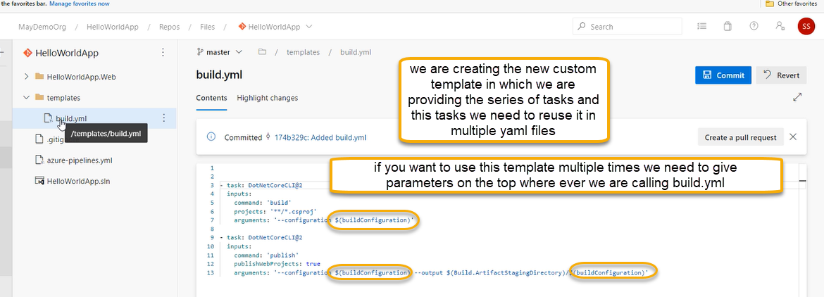

In yaml file build configuration is variable

But now build configuration is a parameter in yml file

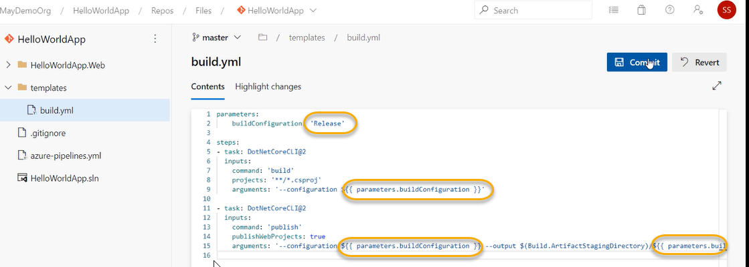

How are we going to reuse this task

Now click on the commit > commit for build.yml file

Now go to the below navigation

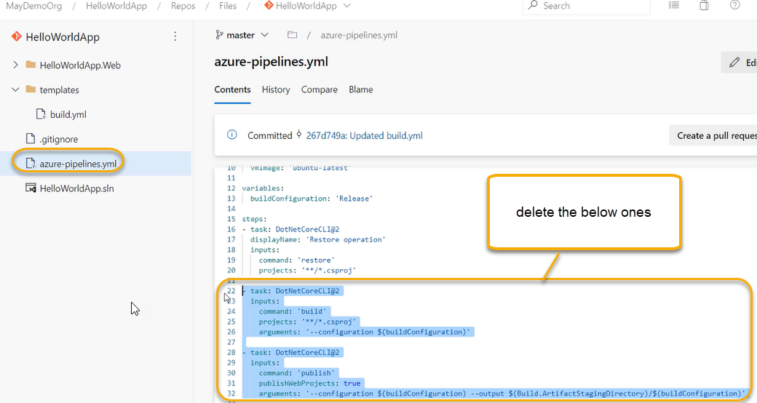

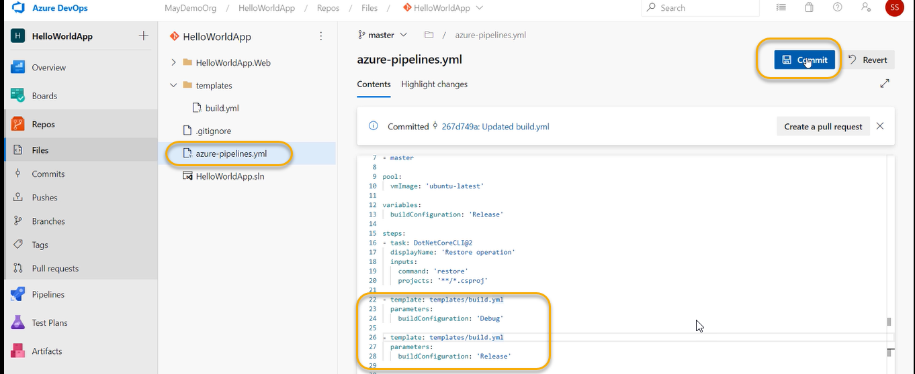

Click on commit > commit

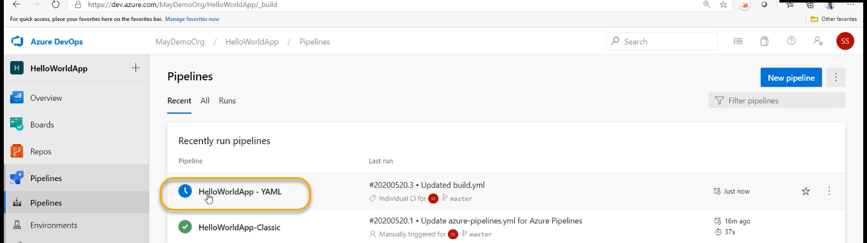

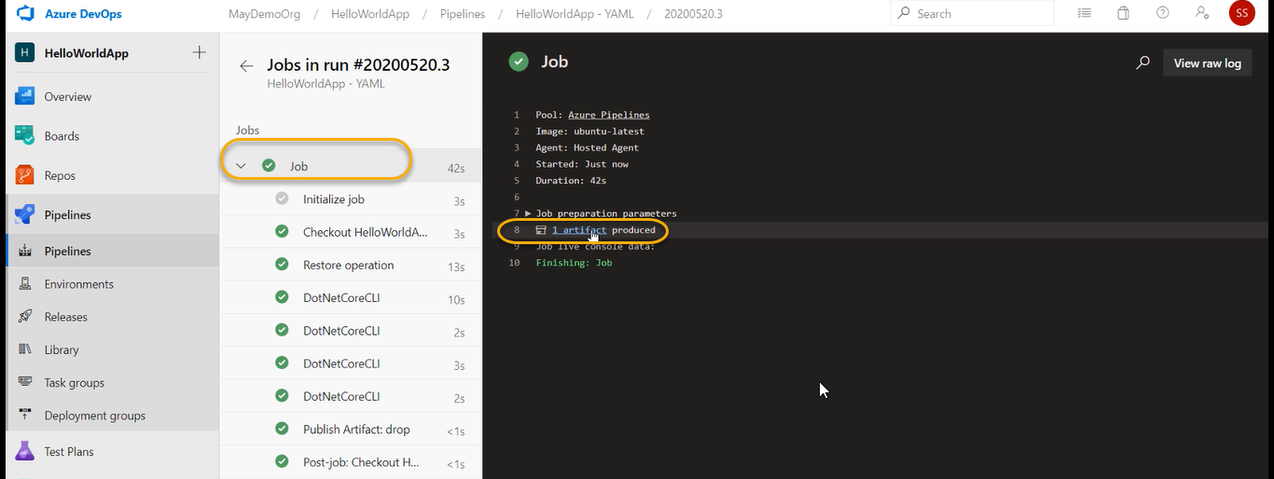

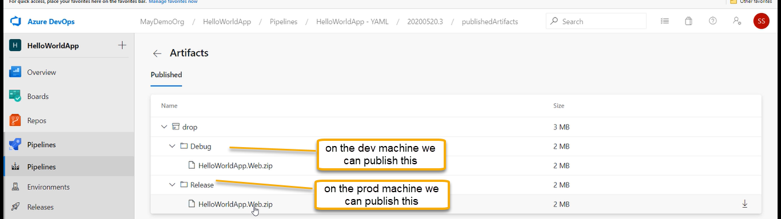

Validating the pull requests based on build pipe line result

1. Previously we can seen if you pull request triggers automatically build should run however it supported in Git Hub and bit bucket and how to achieve in Azure Repos
2. In azure repos we need to use build policy
3. There are multiple developers who are pushing the code

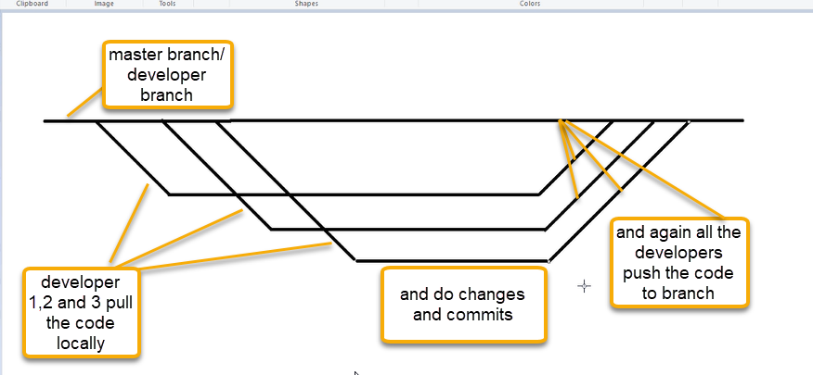

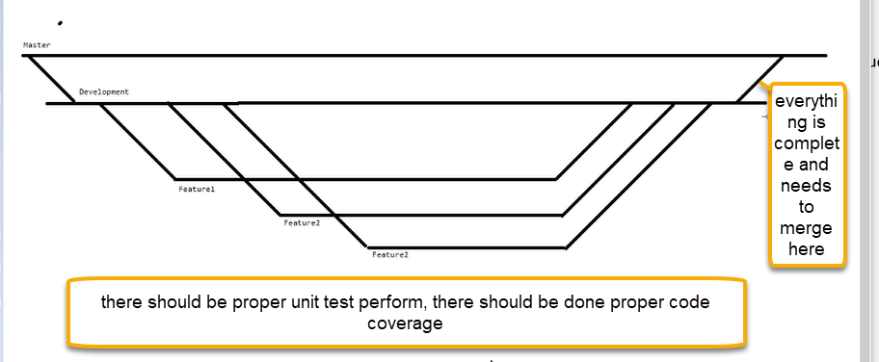

Or task for vulnerability testing

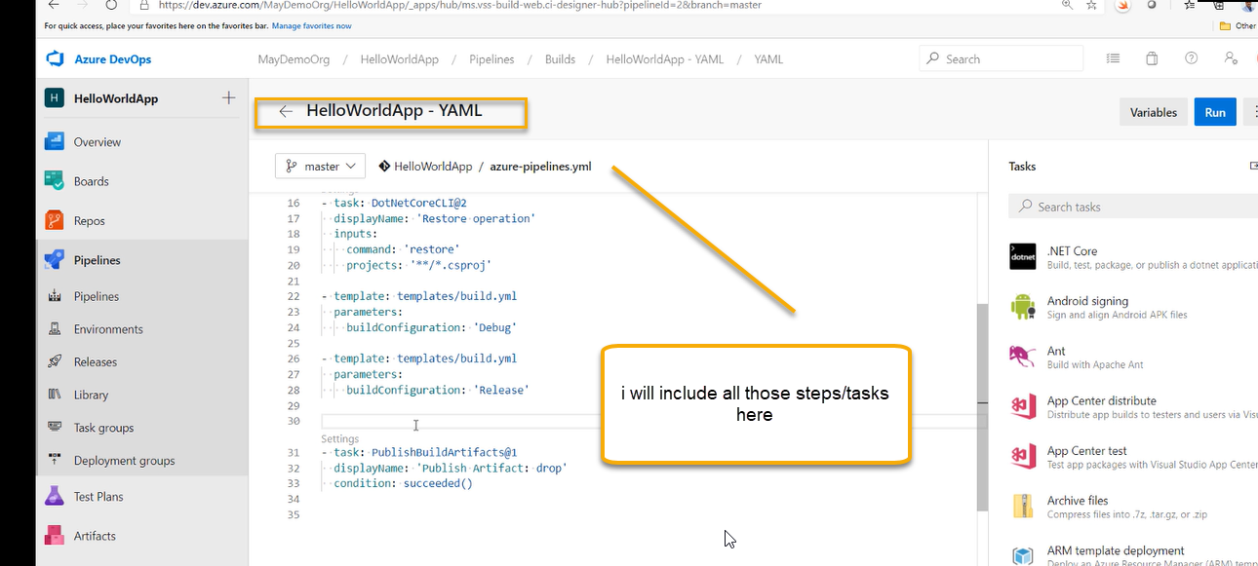

All this testing/steps/tasks has to done for all the developers not for single developers so we need to below naviagation

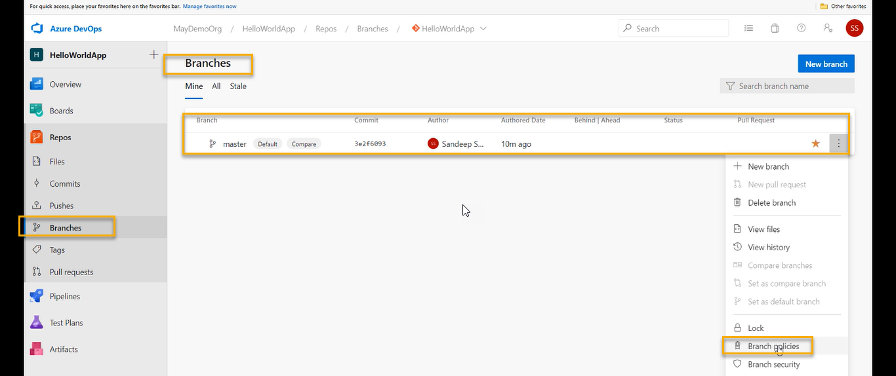

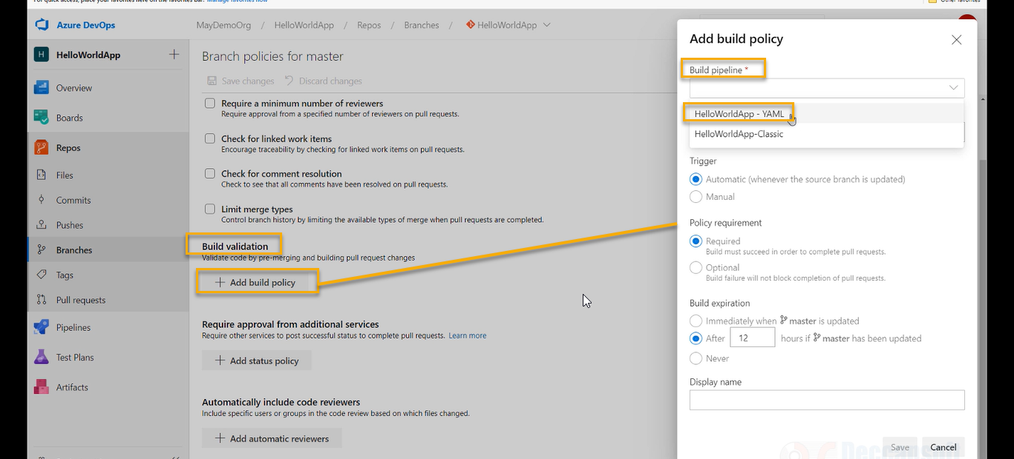

Basically, we are creating the pull request pipeline

And click on save as shown above and we see the below policy has been added



Now direct commit to master branch is NOT allowed and if we tried to do that we will get the below error

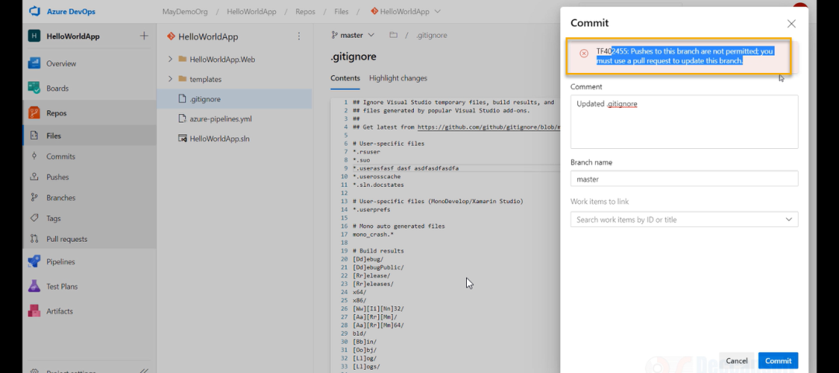

So make changes to feature branch and create the pull request to master branch

Create a new branch

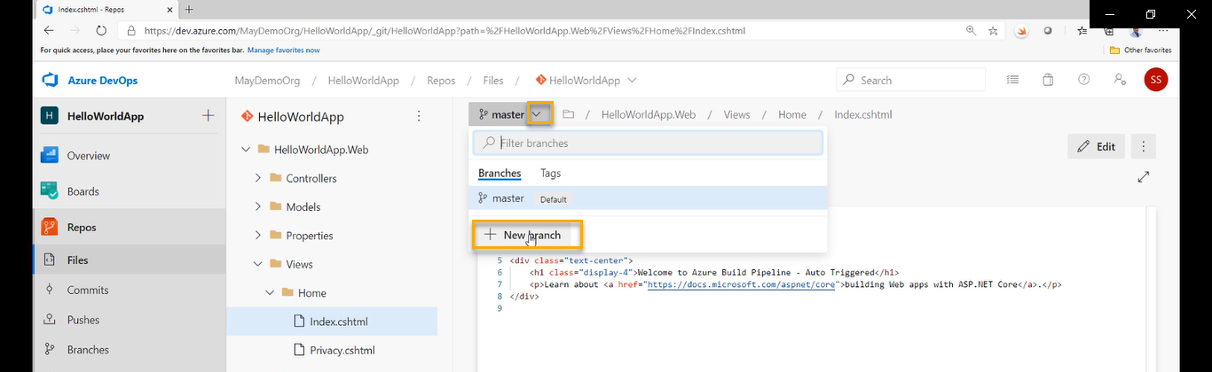

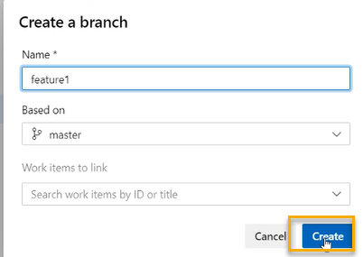

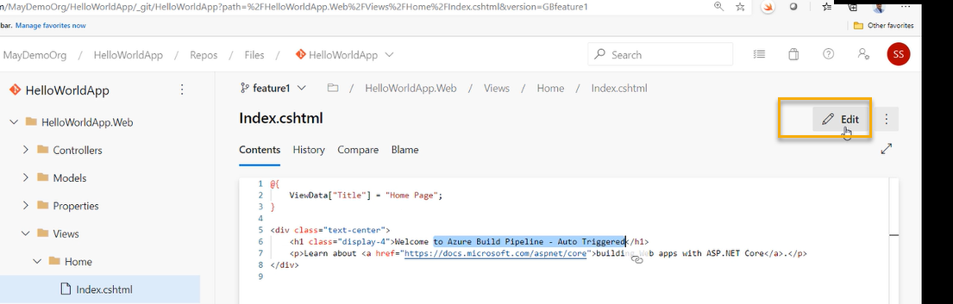

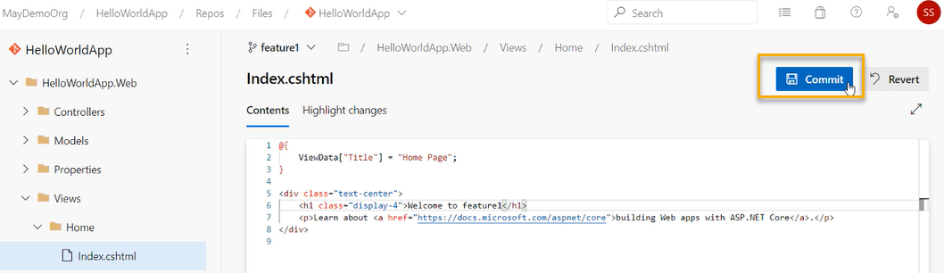

And again click on commit and all the changes are done in feature branch

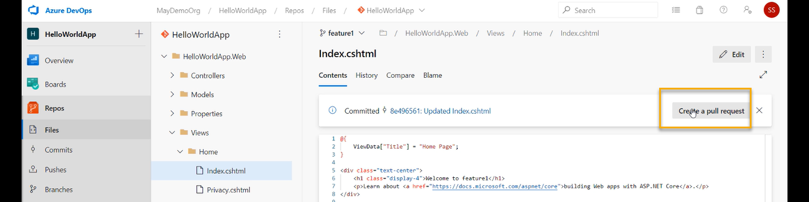

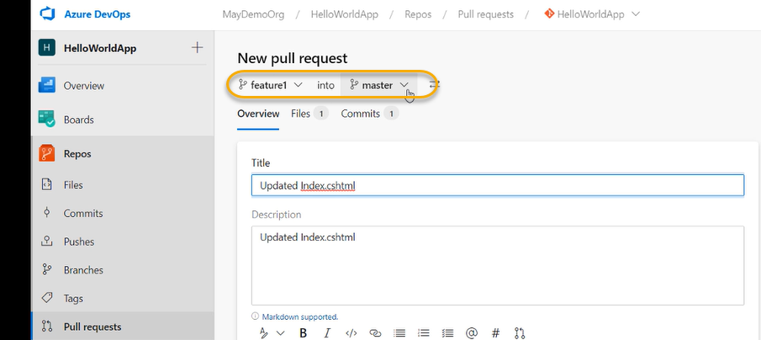

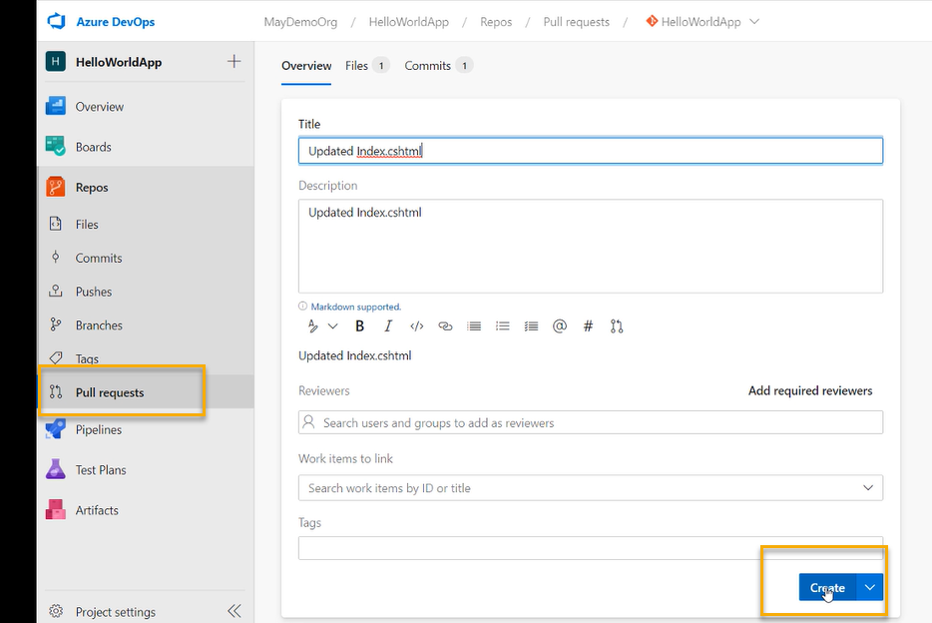

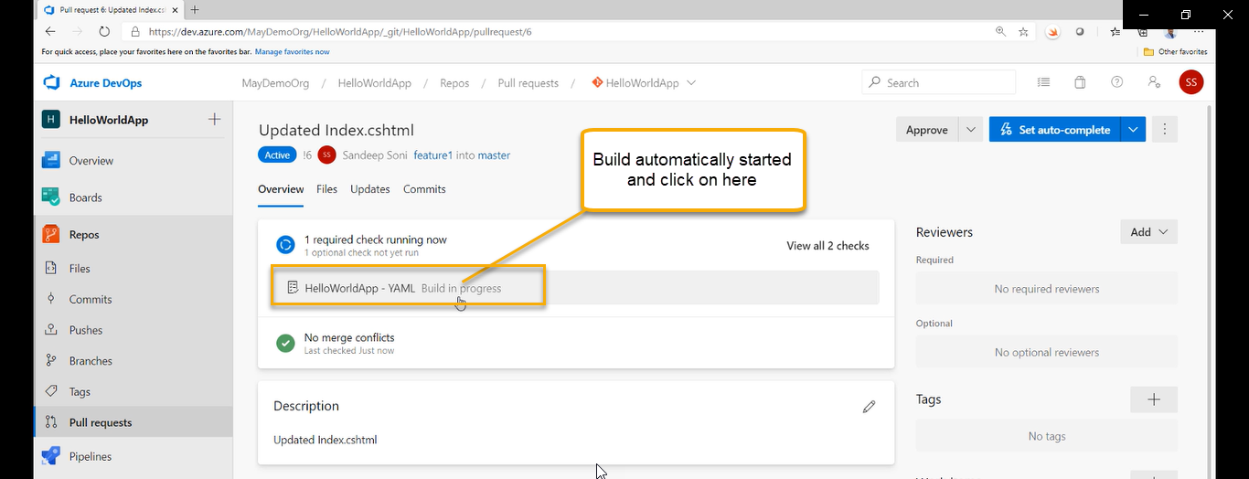

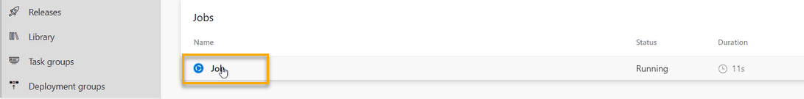

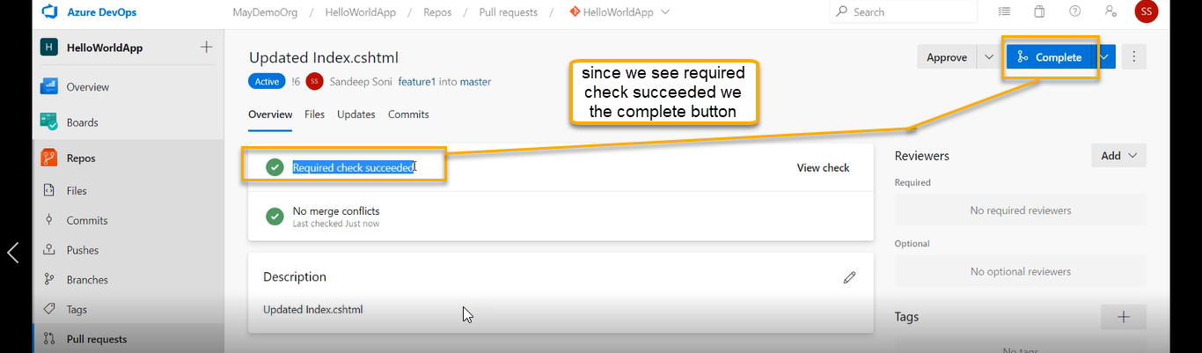

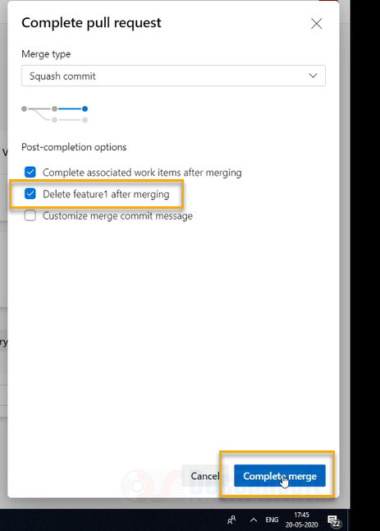

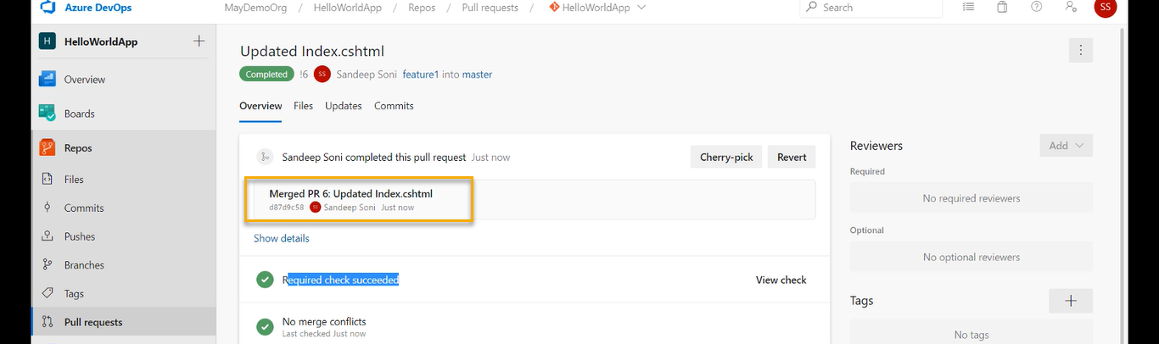

The validation procedure of pull request and if you there is no validation, and you do the pull request with CODE ERRORS it will create the pull request successfully however the build will fail and we see the same belowscreenshot 2

We can set up to auto complete



screenshot 2

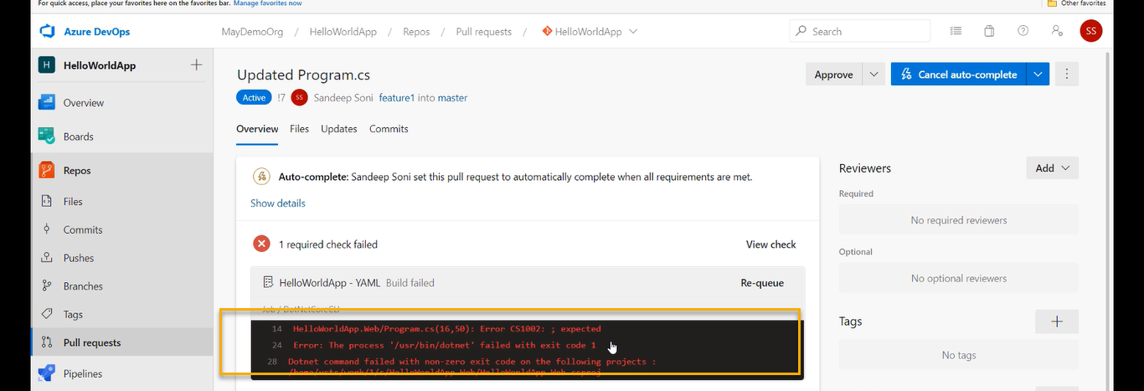

And rectify the changes in code and commit and we observe that pull request will done automatically and the Job will trigger the automatically

Pipeline created automatically because we keep set auto complete

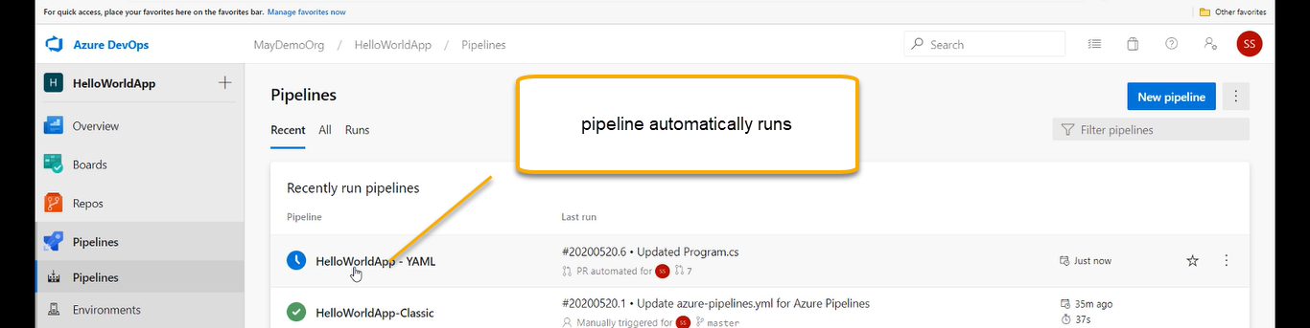

Job created automatically because we keep set auto complete



To over come this we need to define this define in the YAML itself that if the code is good then only pull request will trigger

